**양서림 21000414**

**김사론 21000096**

**이성경 21000494**

**이세규 21100497**

2016 June 18

|  |
| --- |
|  |
| OODP Project |
|  |
| Final Report |

**Goal description**

The goal of the project is to make a library system that keeps track of members, books, DVDs and journals that are in the database. Separate user interface will be provided for administrator and members of the system. User interface for administrator will include functions that include managing new and current members of the library as well as handling and keeping record of new books, DVDs, and journals. The administrator can add, delete or modify any member information as well as books, DVDs, and journals. In addition to the items and member management, the system will also provide a separate panel for list of borrowed books by the member with information of the member’s name, ID, registered date, type of item borrowed, and name of the item borrowed. In the User interface for the members of the library functions such as search, borrow and return will be available. Members will be able to search, borrow, and return books or DVDs. Only search function will be provided for journals. Search function will allow members of the library system to search according to the criteria provided by the user which are search by title, search by author, and search by publisher.

**UML Diagram of Implemented System**

**Use Case Diagram** (Final)

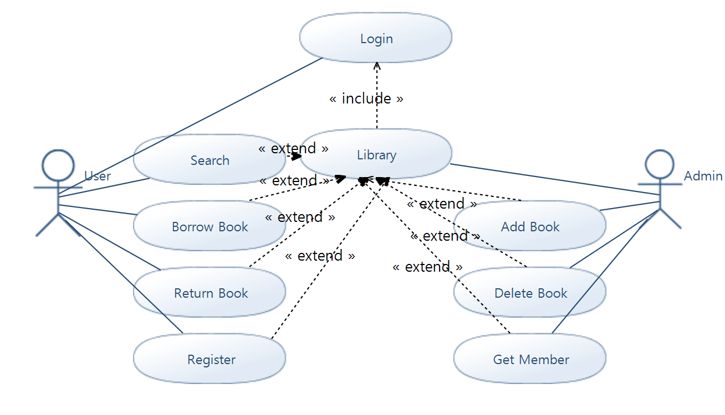

**First Iteration**

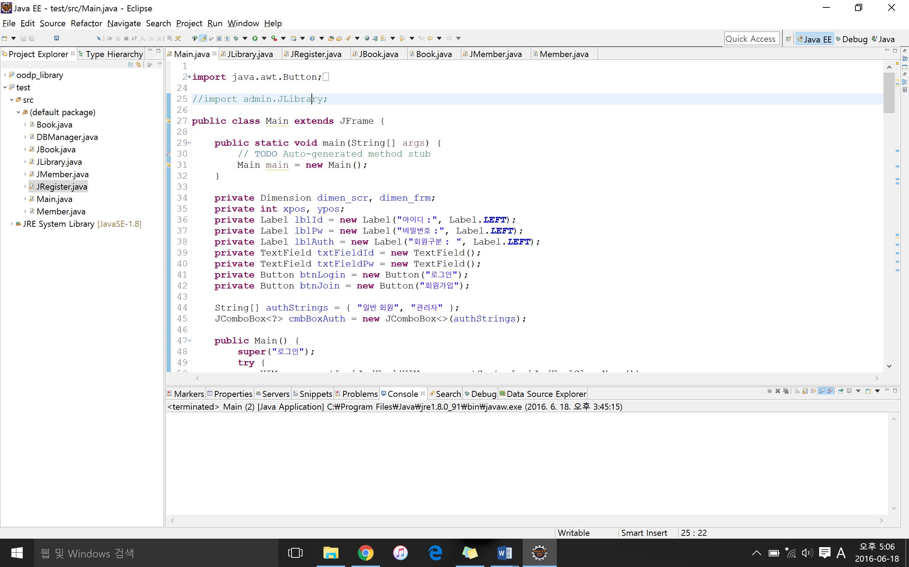  
<Figure 1.1>

In the 1st iteration we implemented 8 most basic classes for the library system. We made three different classes for the interface that extends JFrame and 3 classes for Book, Member and Main as shown on the screenshot above. The JLibrary is the interface that pops up when the program is executed. It is the window that allows us to log in to the library interface. In the 1st iteration we had an integrated interface without separating the administrator and member interface. The functions that were available included register, add book, add member, modify member. Register function stores user ‘s id and password to the database. The database is shared by the member interface that allows adding and modifying of the basic member information. The add book function stores book’s title, author, and ISBN to the database.

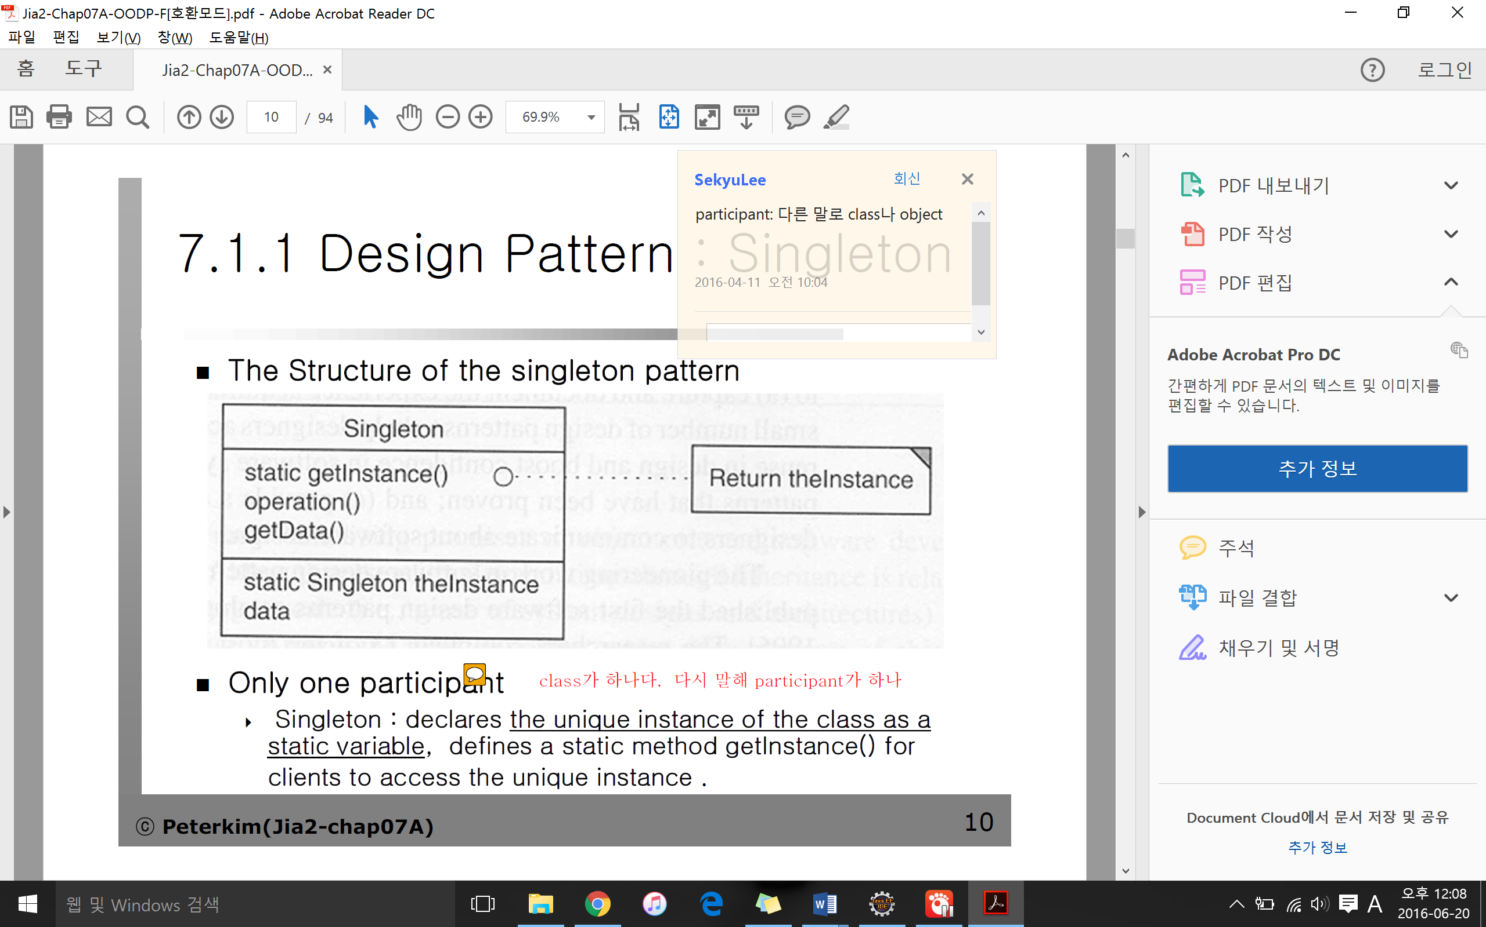  
<Figure 1.2 – Structure of the singleton pattern>

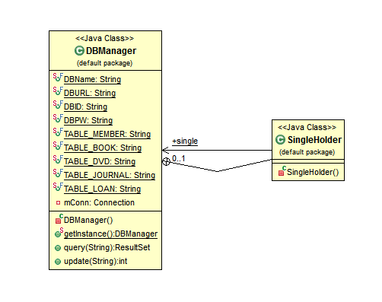  
<Figure 1.3 – Structure of singleton design pattern: library system>

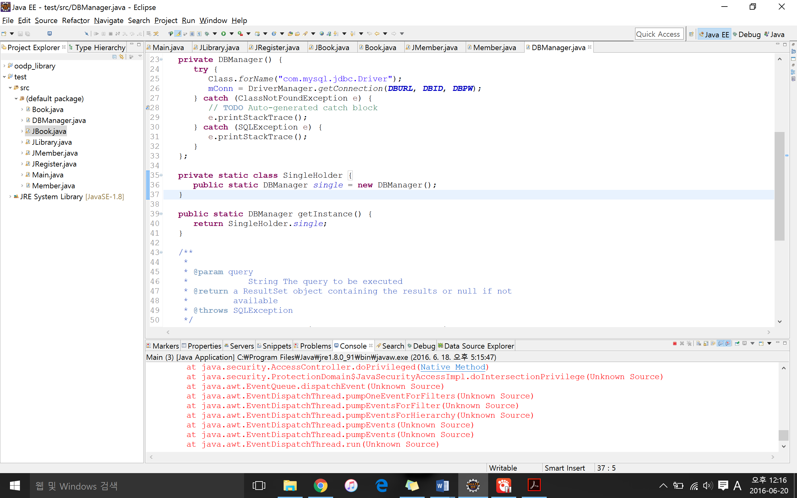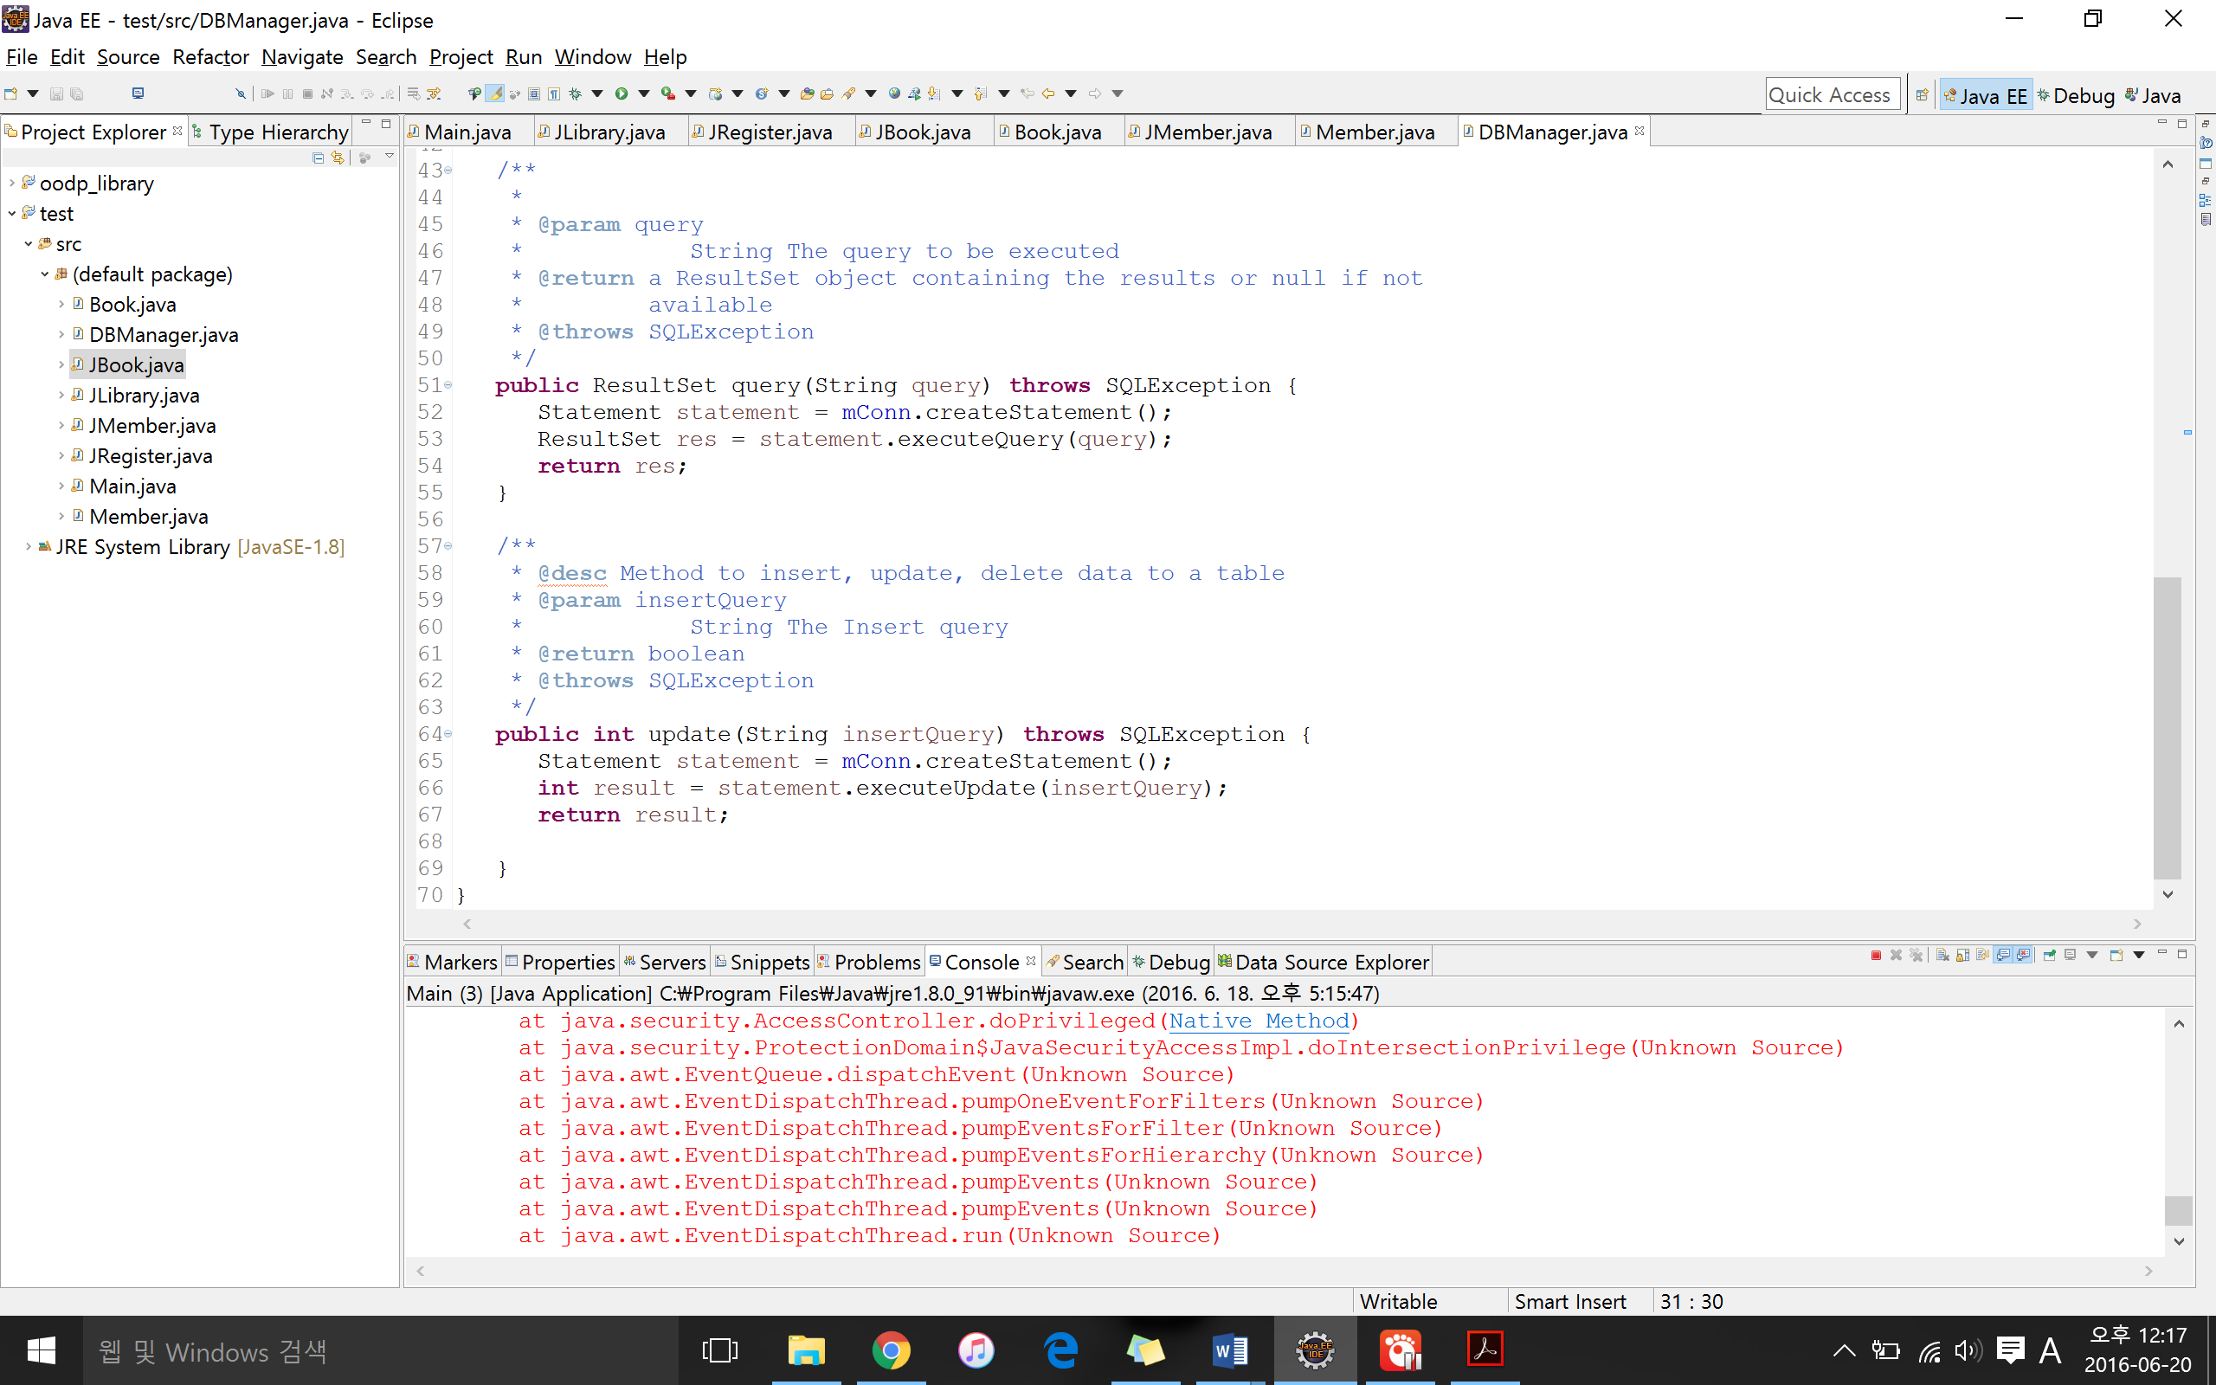

<Figure 1.4 – singleton: Library System code>



<Figure 1.3 – singleton: example from the book>

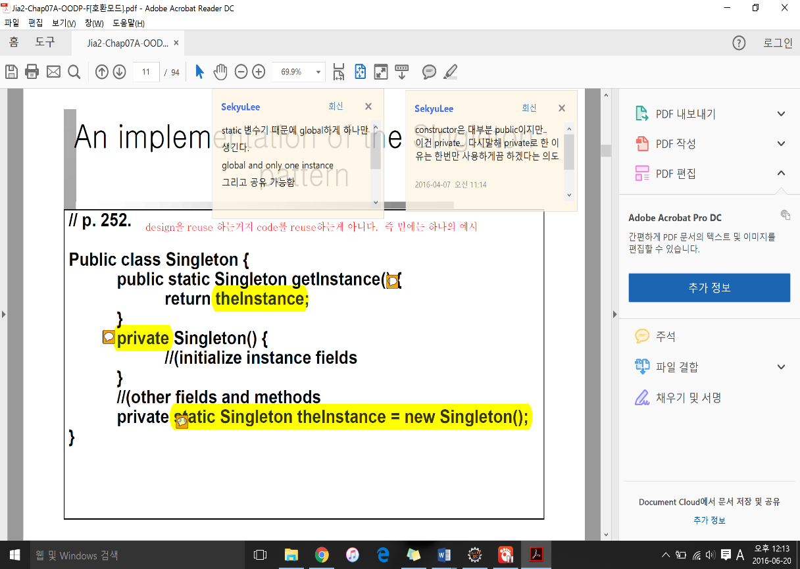

The only design pattern we implemented in the 1st iteration was the singleton design pattern. We declared one unique instance of DBManager and SingleHolder class as a static variable and defined static methods DBManager() and getInstance() for users to access the unique instance.

**Second Iteration**

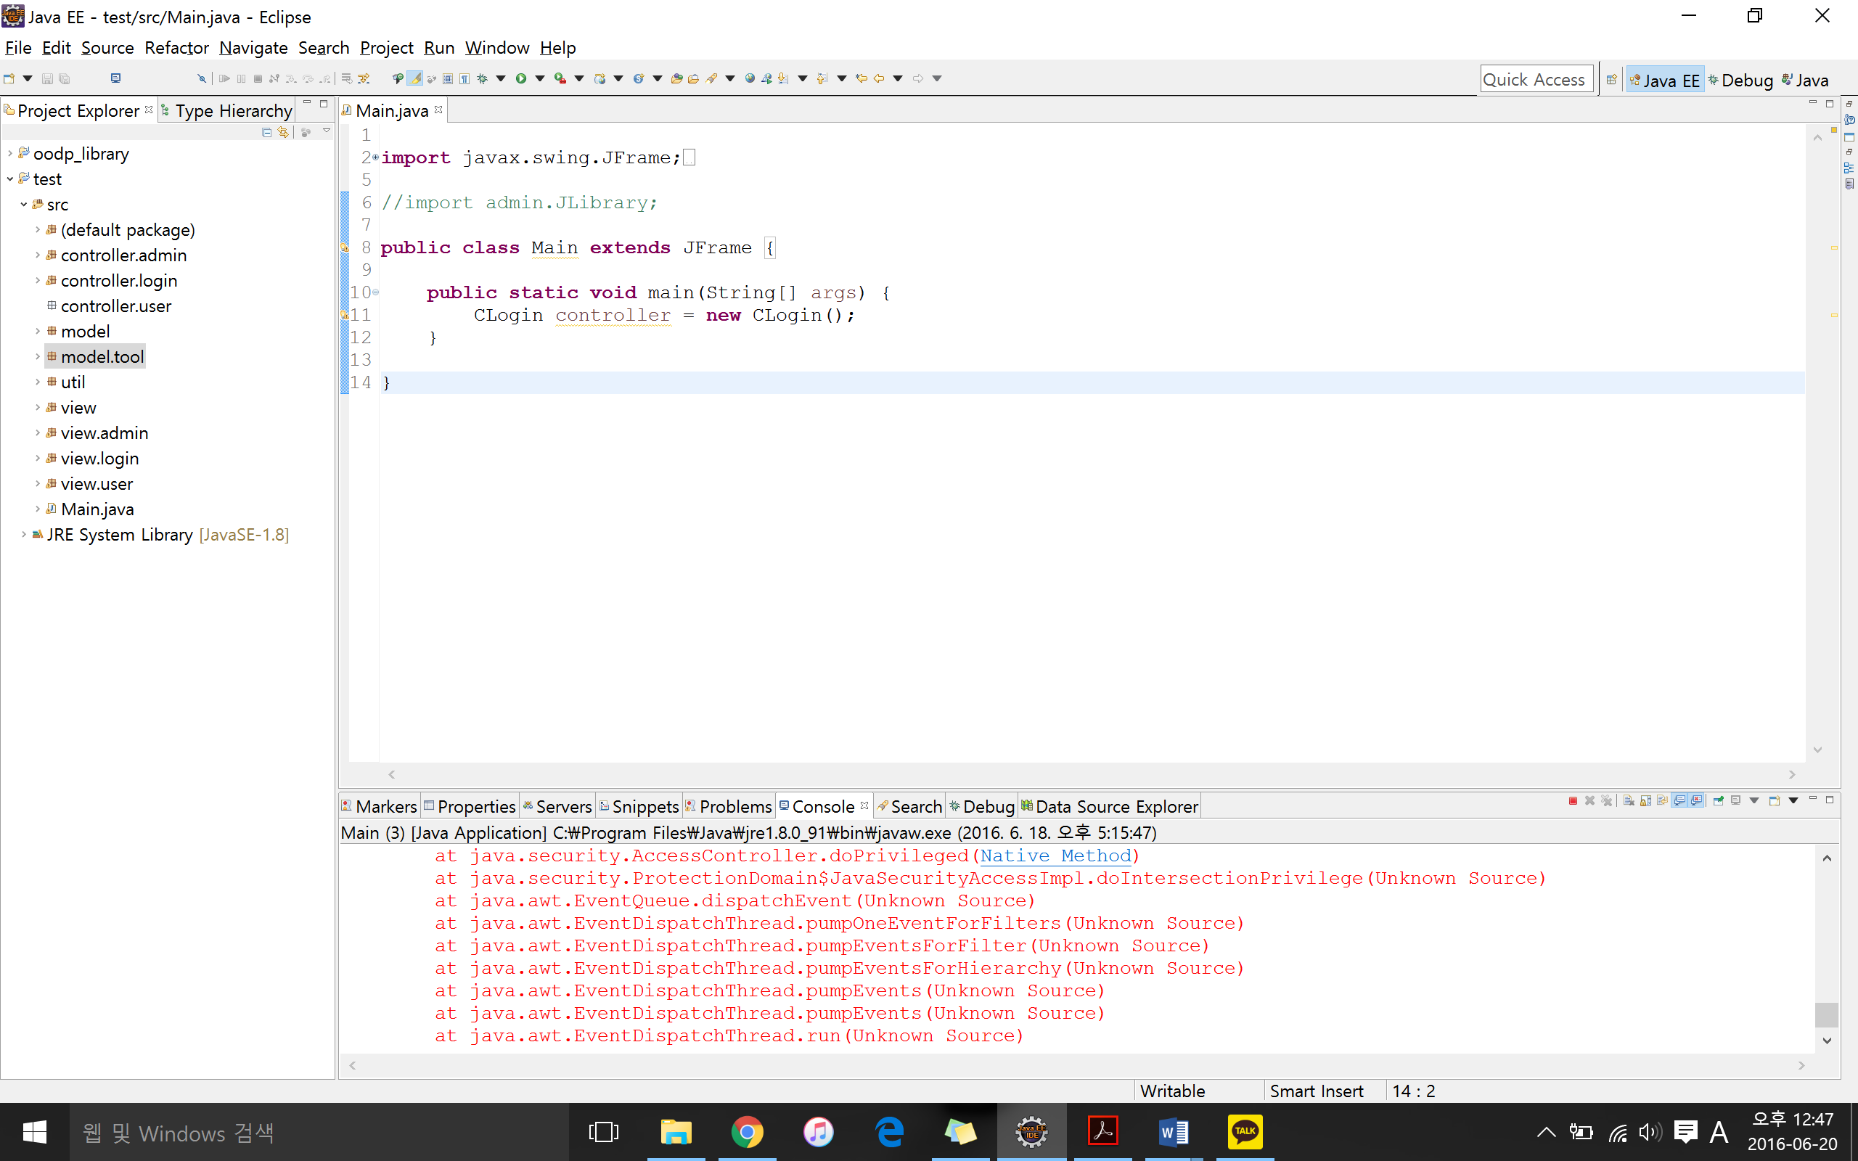<Figure 2.1>

In the 2nd iteration we made major changes. The changes we made in the 2nd iteration include the new functions for the Library System and refactoring of the recurring code segments and identical codes. In order to refactor, we implemented the model view control design pattern.



<Figure 2.2 – Refactoring>

**Class Diagram: MVC (2nd Iteration)**

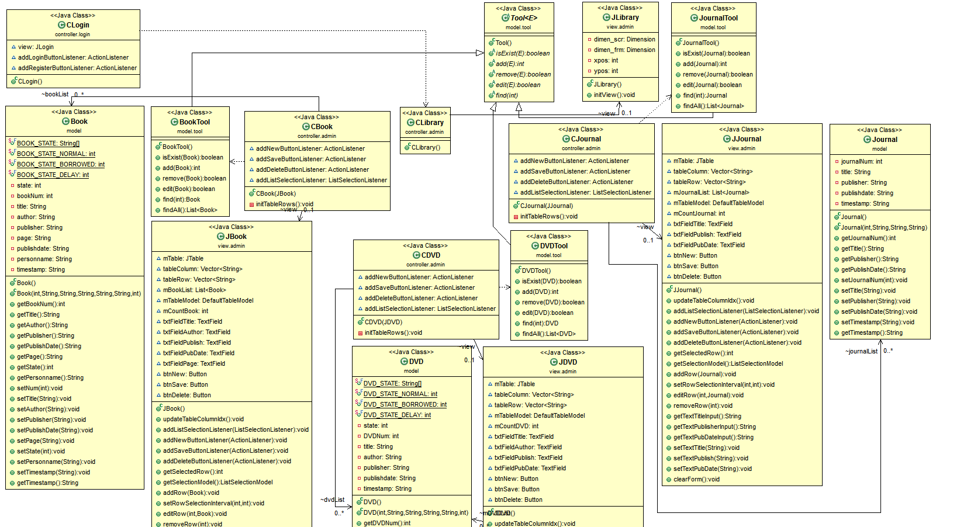

<Figure 2.4 – Class Diagram: Admin>

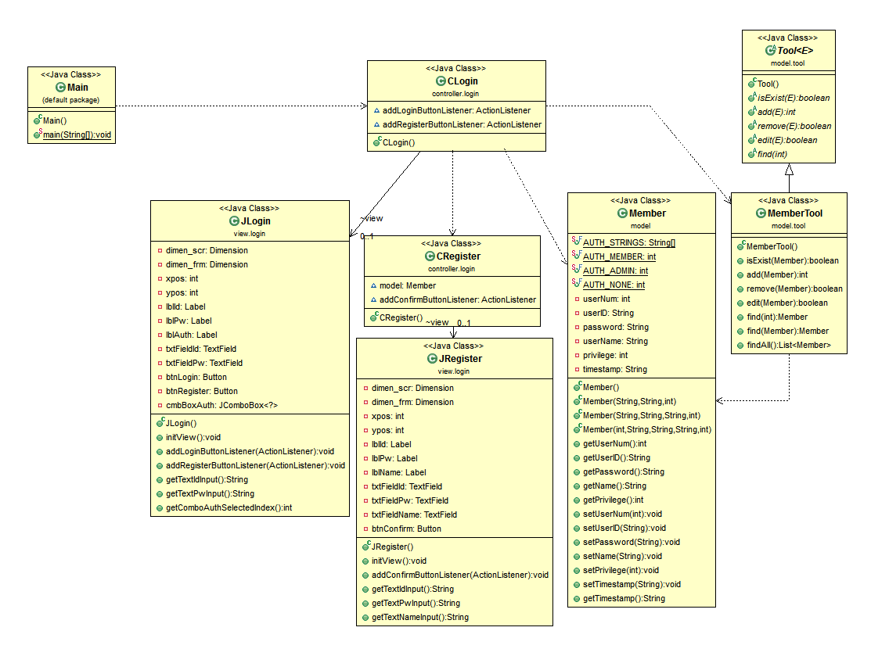

<Figure 2.3 – Class Diagram: Login>

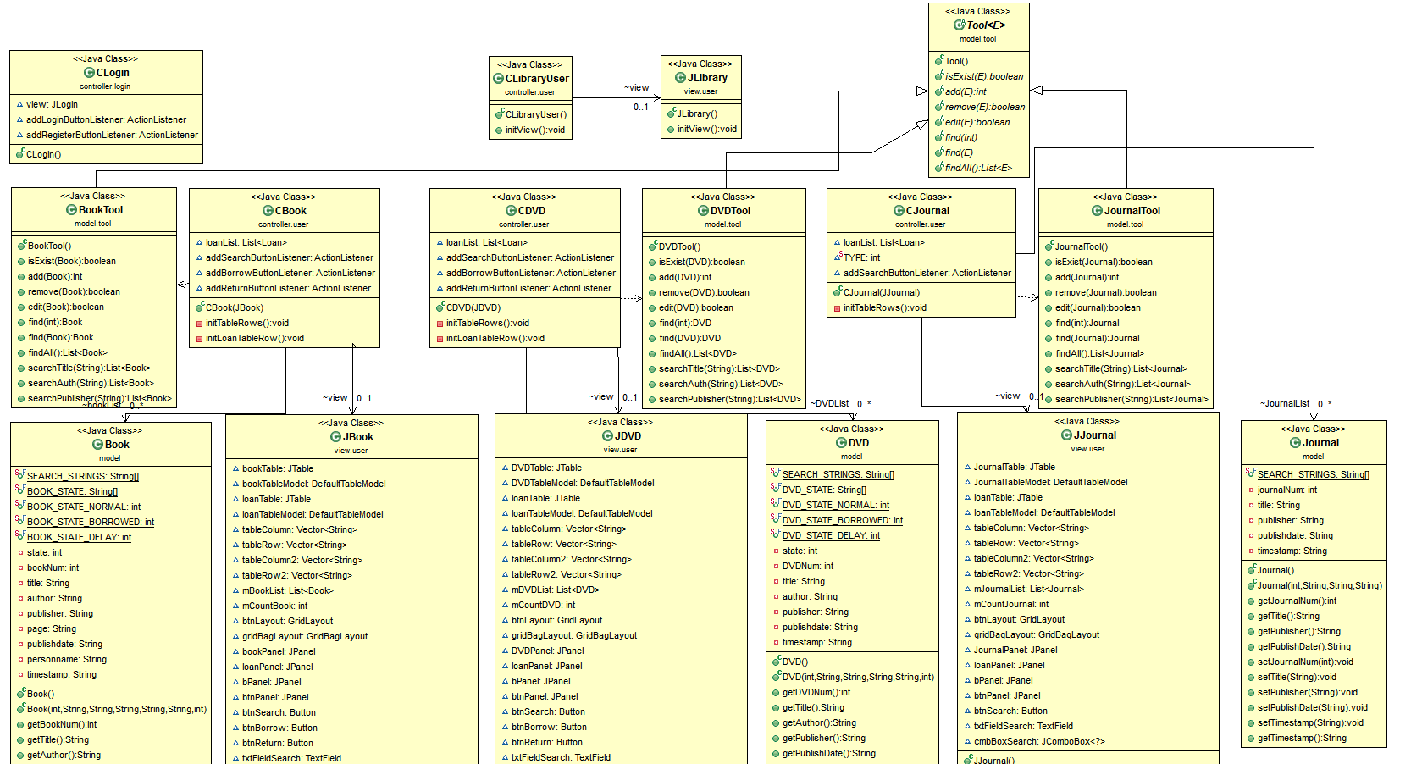

<Figure 2.5 – Class Diagram: User>

**New Functions**

In terms of functions the biggest modification that was made was the separation of the interface for member and administrator. When executing the library system for the first time we grant the user either a privilege value of 0 or 1. If the user’s privilege is 1, the user is an administrator, otherwise the user is an ordinary member. The administrator mode administrates the members of the Library System as well as the items in the Library System whereas member mode only gives users the privilege to look up and borrow books.

Also we added DVD and journal to the list of items. Therefore, we implemented the same search, return, and borrow functions to DVD and journals in both the user mode and the administrator mode. The difference between the items is that in book item and DVD item, the user can search, borrow and return. However, the journal item has only the look up function.

**Design Pattern Applied**

In terms of design pattern, we applied the model view control design pattern. The model is the business logic of the application. It is the collection of components responsible for data objects. The view decides the kind of interaction it will have with different classes. It is responsible for the input and the output of the data. The control is responsible for the whole system. It controls the flow as well as updating the view and the model.

<Figure 2.6 – MVC Design Pattern>

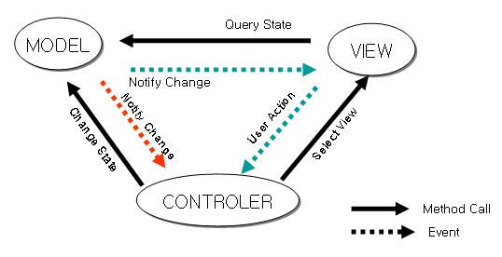

<Figure 2.7 – MVC Design Pattern>

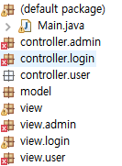

As shown in figure 2.4 above, when we execute the program, the main class creates an instance from the controller package. We divided the model, view, and controller into different packages. The model is responsible for the collection of data objects such as the book, DVD, journal and member. The view decides how the system will be expressed. We have different view packages for admin and user because we made separate interfaces for administrator and members. Finally, the controller package contains all the code necessary for the interaction between the model and the view.

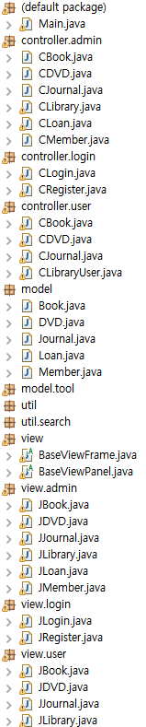

<Figure 2.8 – MVC Library System Class (Admin)>

The classes in the model, view and controller packages each perform their responsibilities. CLibrary and JLibrary class, for example, inherits JFrame to create the most basic frame of the interface when logged in as administrator mode.

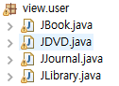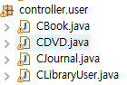

<Figure 2.9 – MVC Library System Class (User)>

The application of user package is similar to that of the admin package. However, model can be shared by the administrator and user mode, therefore there is no need to create different model for admin and user. We have refactored the Book, DVD, and Journal Classes to use it in both administrator mode and user mode.

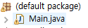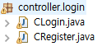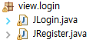

<Figure 2.10 – MVC Login & Register>

We applied the MVC design pattern to the login function of the Library System as well. The controller class is instantiated by the main class and the controller CLogin and CRegister decides the interaction of between data and how it will be shown to the user. Data output is therefore expressed by JLogin and JRegister class, using the member class and the member tool class.

The code below is the example of Book object with MVC design pattern applied:

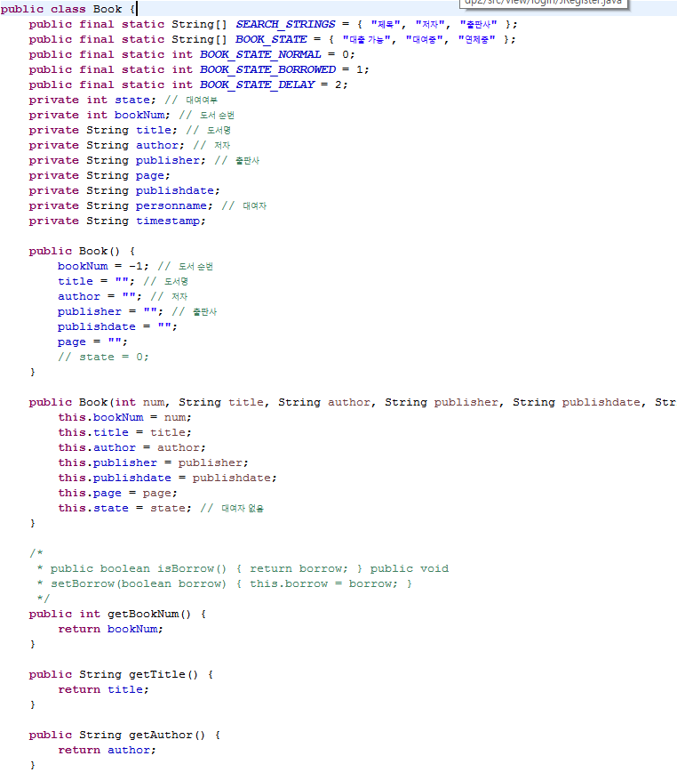

<Figure 2.11 – Model.Book>

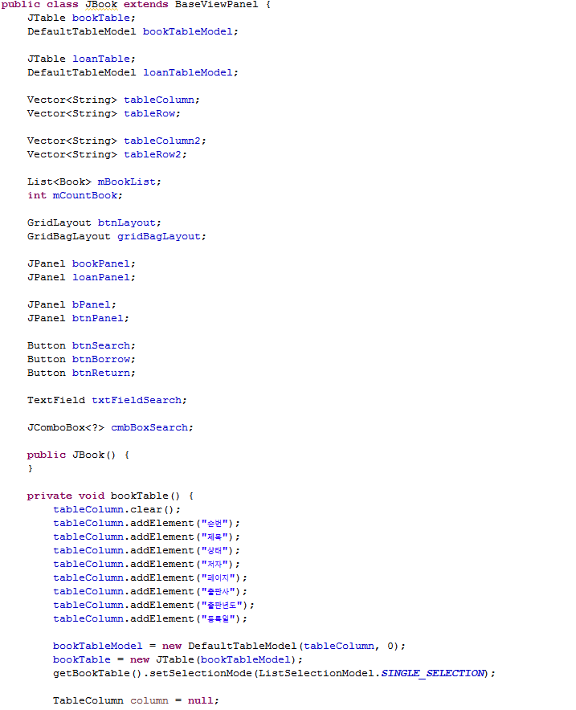

<Figure 2.12 – View.Book>

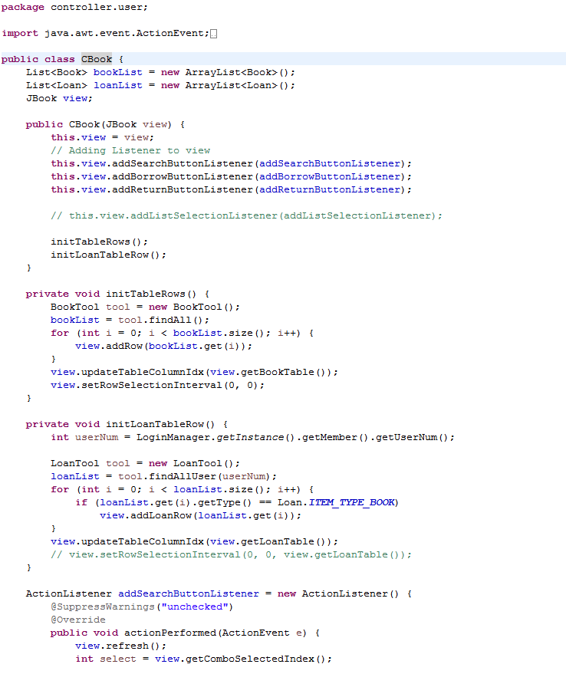

<Figure 2.13 – Control.Book>

The codes above are model, view, and control for Book object. In the model code exists all the necessary information in creating a Book instance and in addition to the information, it has the methods that are required in the controller. In the view code have the codes to express the output formats depending on the requests from the controller. Button and panel as well as table, which are what the users actually use to interact with the Library System, are implemented in the view code. The control code implements the listeners for or updates and the instantiation of objects that are requested from the view code.

**Third Iteration**

**Class Diagram: Template Method (3rd Iteration)**

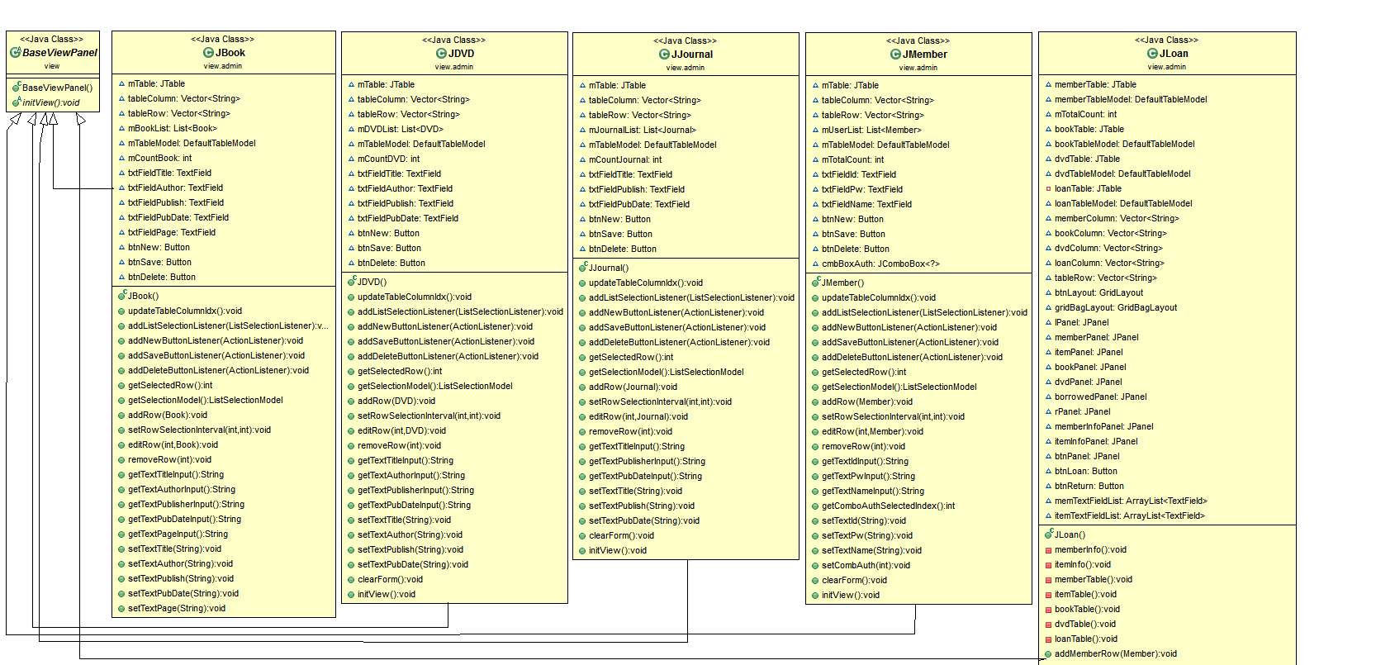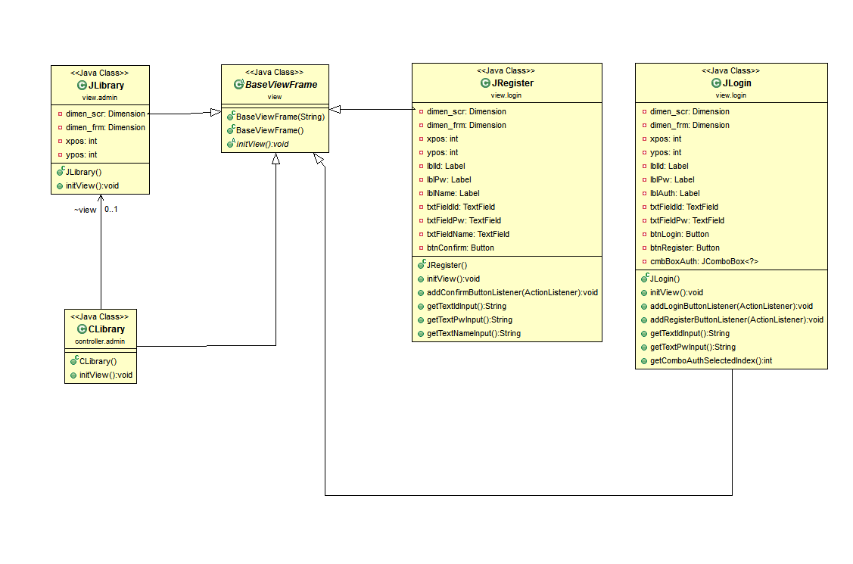

<Figure 3.1 – Library System: Template Method Design Pattern >

**Class Diagram: Strategy Method Design Pattern (3rd Iteration)**

<Figure 3.2 – Library System: Strategy Design Pattern>

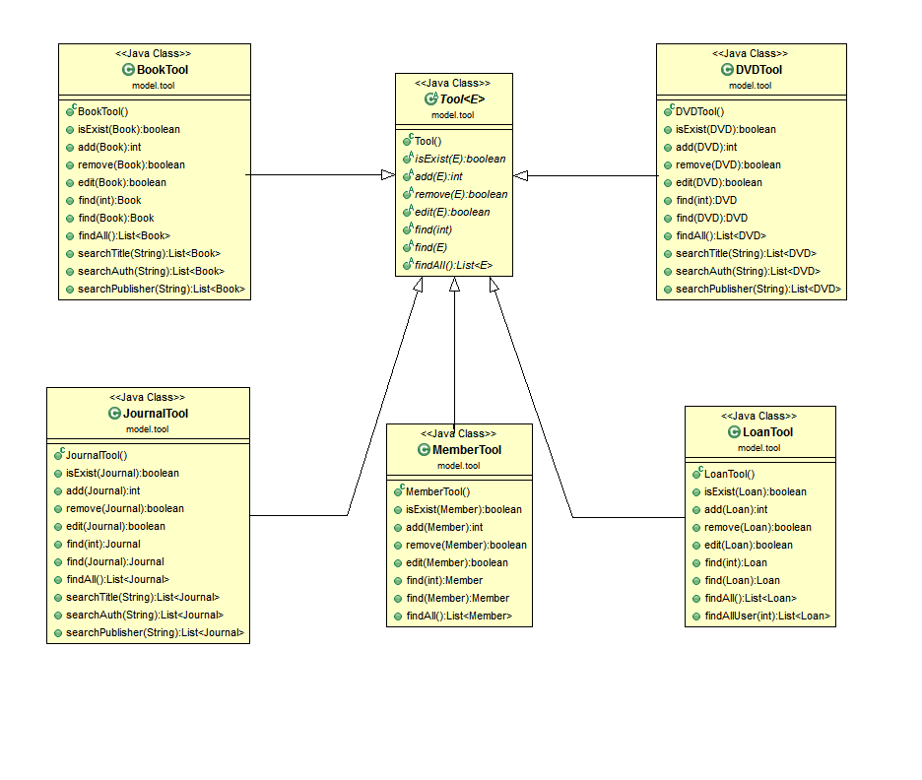

**New Functions**

In the 3rd iteration, we finalized the implementation of library functions such as the search and borrow and return function in the member interface. In the second iteration we had completed up to adding, deleting and modifying of the different items in the administrator interface. In the third iteration we finalized the implementation of library function from the user perspective. The functions that we added are search of the items by title, author or publisher, borrow book. We also implemented the borrow and return function in this iteration.

**Design Pattern Applied**

The design pattern that we applied for the third iteration are the template method and strategy design pattern. Template method lets subclasses redefine certain steps of an algorithm without changing the algorithm’s structure.

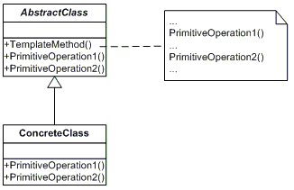

<Figure 3.3 – Template Design Pattern >

Abstract class defines the abstract primitive operations that concrete subclasses define to implement steps of an algorithm. The concrete class implements the primitive operations to carry out subclass-specific steps of the algorithm. In our project, the abstract class is the BaseViewFrame and the BaseViewPanel class. The concrete classes are the JBook, JDVD, JJournal, JMember and the JLoan class. The primitive operation therefore would be the method initView() that is implemented in all the concrete classes.

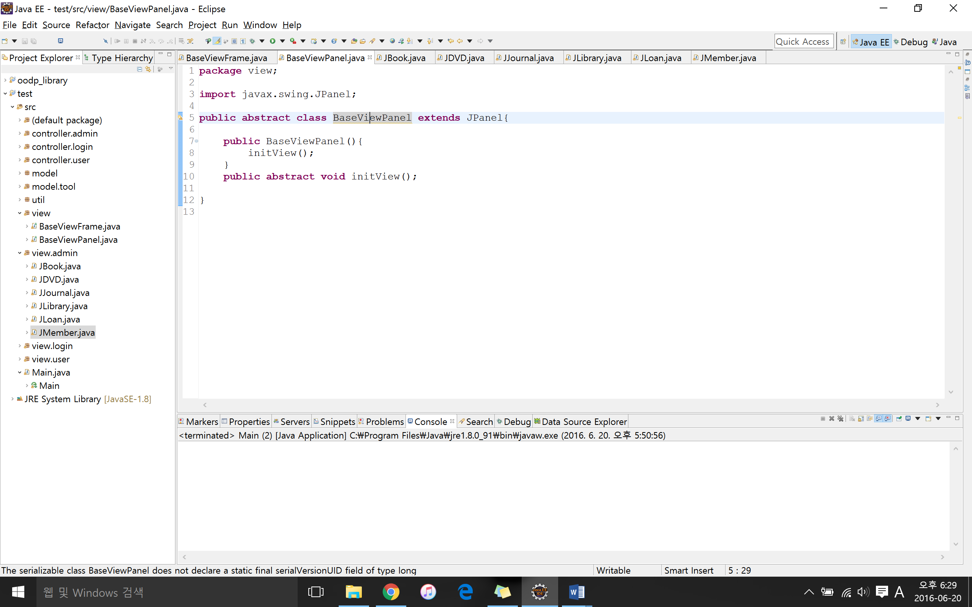

<Figure 3.4 – Template Design Pattern: BaseView >

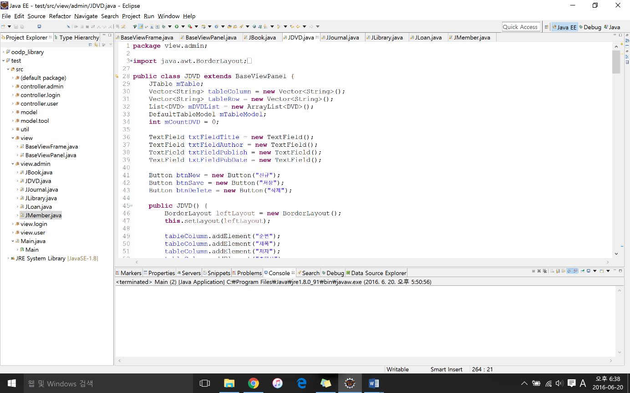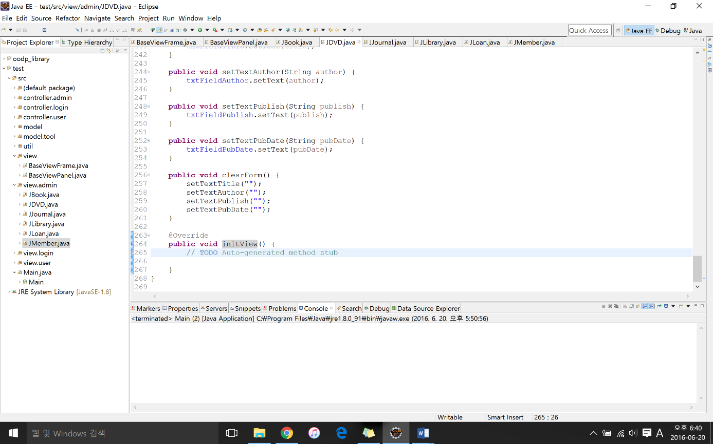

<Figure 3.6 – Template Design Pattern: JDVD >

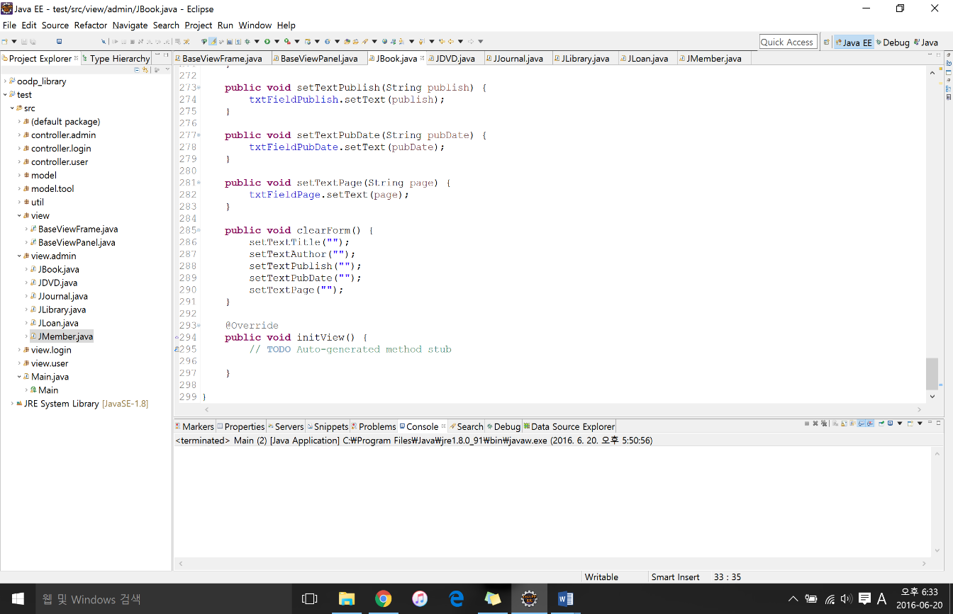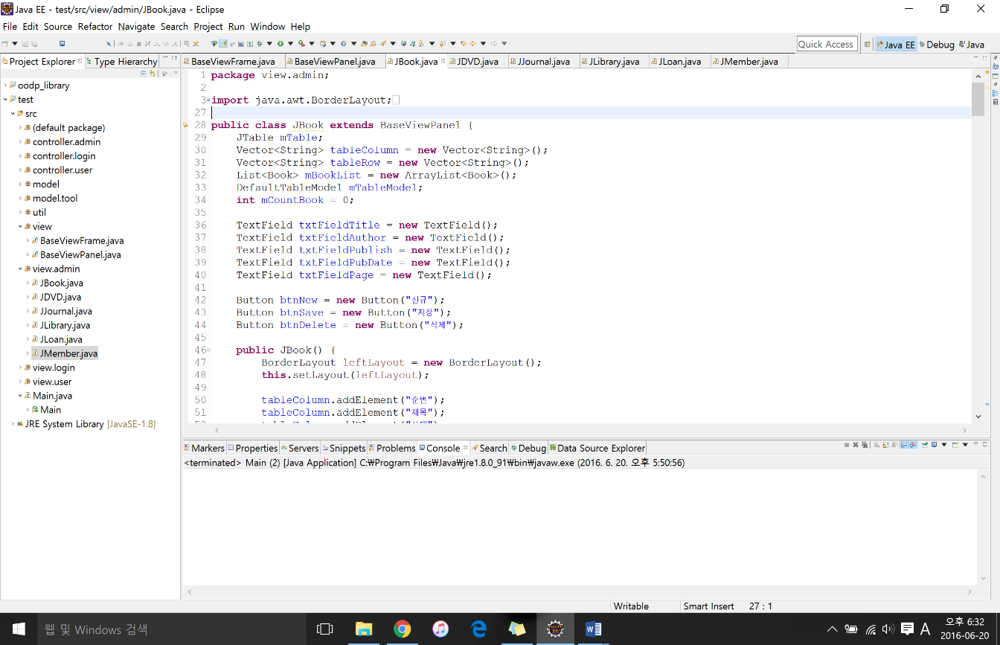

<Figure 3.5 – Template Design Pattern: JBook >

As we can observe from figure 3.5 and figure 3.6, JBook class and JDVD class extends from the BaseViewPanel. BaseViewPanel class has the primitive operation initView(). However the primitive operation that JBook and JDVD implements are the initView() method that are in their respective classes.

Another design pattern that we applied is the strategy design pattern.

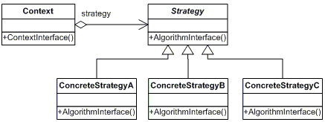

<Figure 3.7 – Strategy Design Pattern Structure>

Strategy design pattern defines a family of algorithms, encapsulate each one and make them interchangeable. Strategy lets the algorithm vary independently from clients that use it. In the Library System strategy pattern was implemented in the Tool class and the subclasses of Tool class which are BookTool, DVDTool, and JournalTool class. The Tool class have the different methods that are required for the Book, DVD, and Journal class. Some of the methods that are included in the Tool class are add(), remove(), edit(), isExist(), find(), and findAll() method. These Tool class methods are applied in the subclasses.

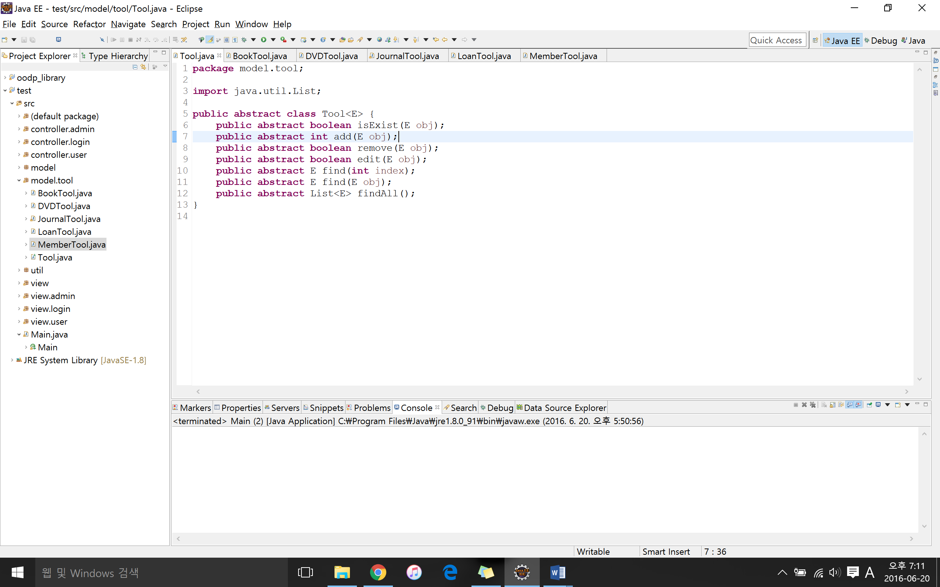

<Figure 3.8 – Strategy Design Pattern: Tool>

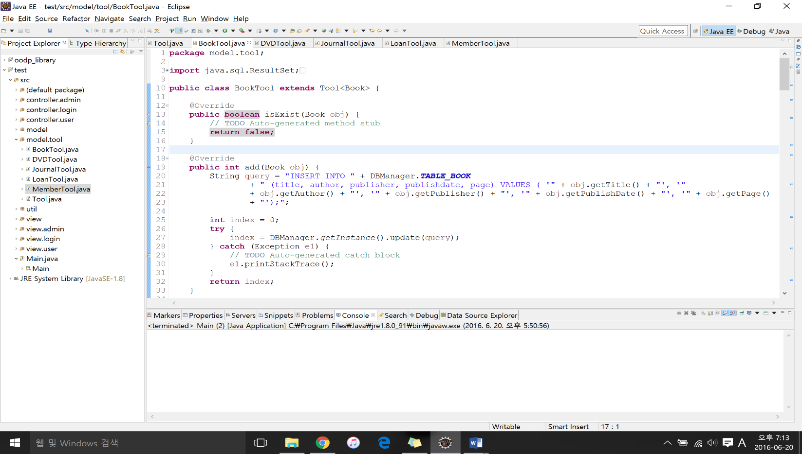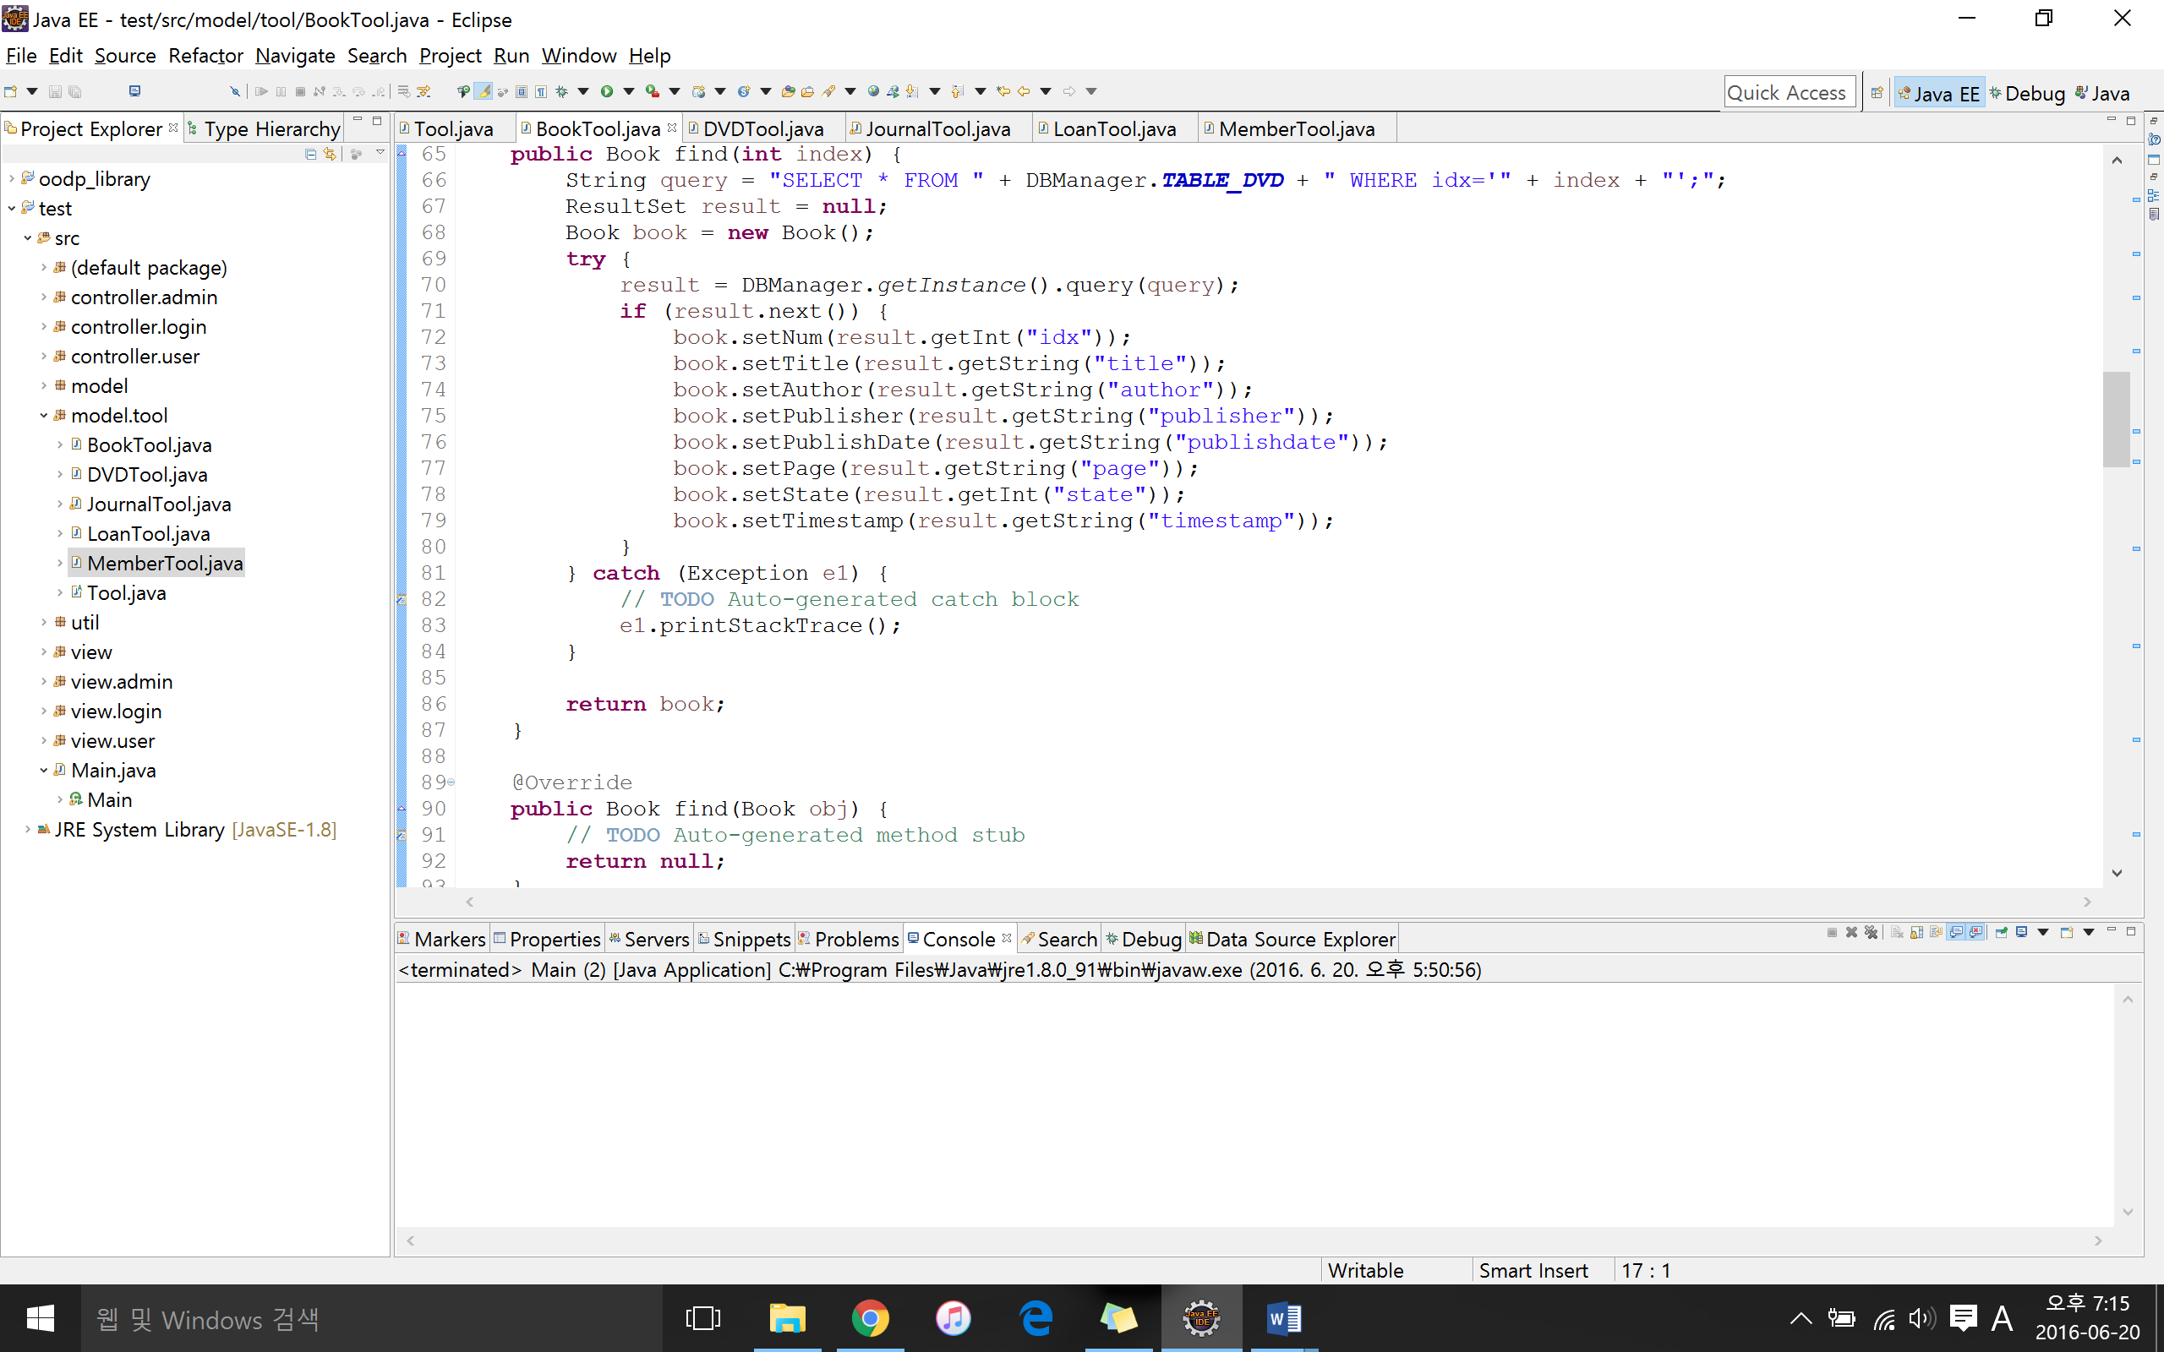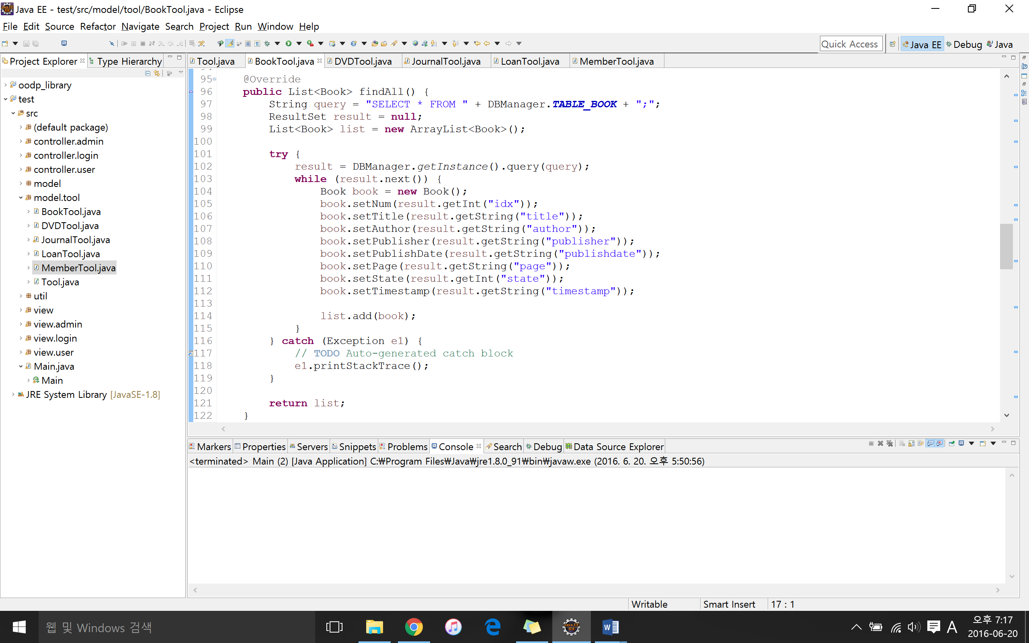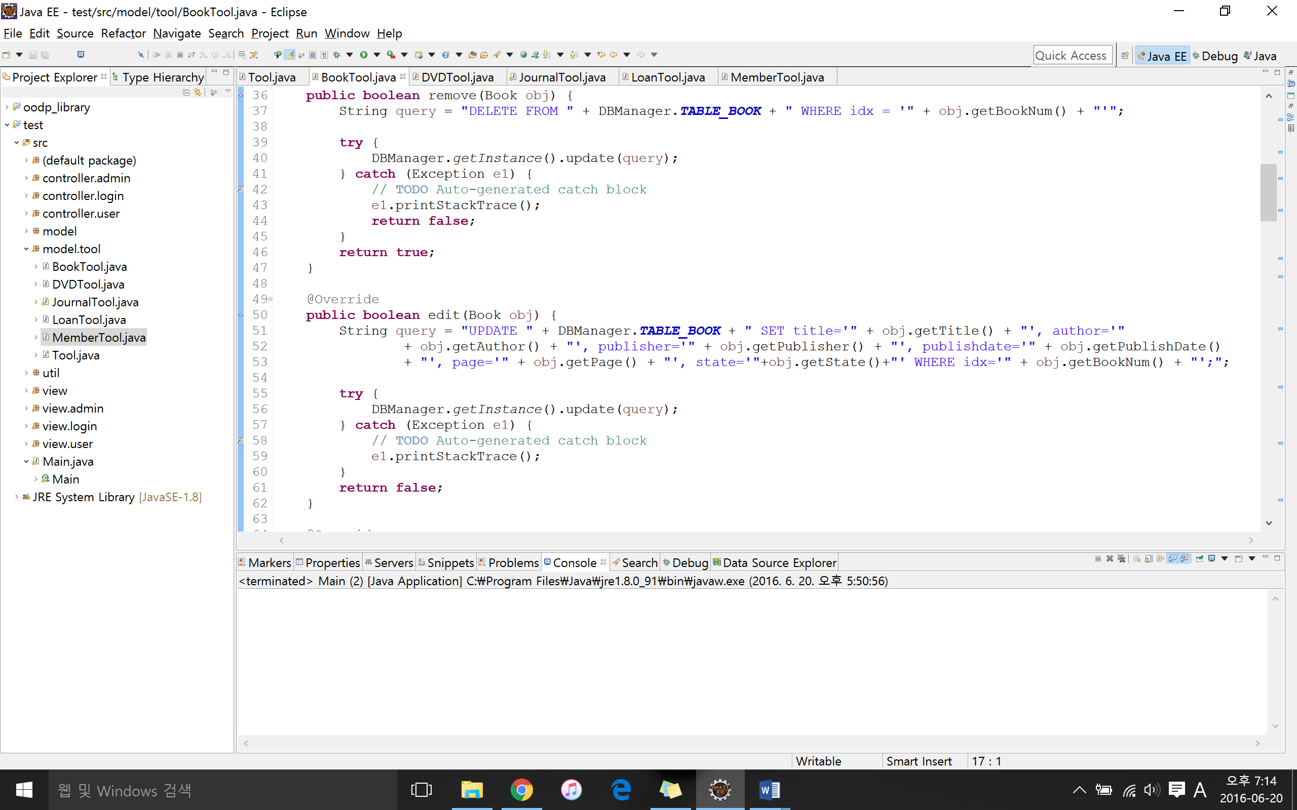

<Figure 3.9 – Strategy Design Pattern: BookTool>

The same methods are applied to the DVDTool, JournalTool, LoanTool, and MemberTool.

**Fourth Iteration**

**Class Diagram: Filter, Builder, and Factory Design Pattern**

Book

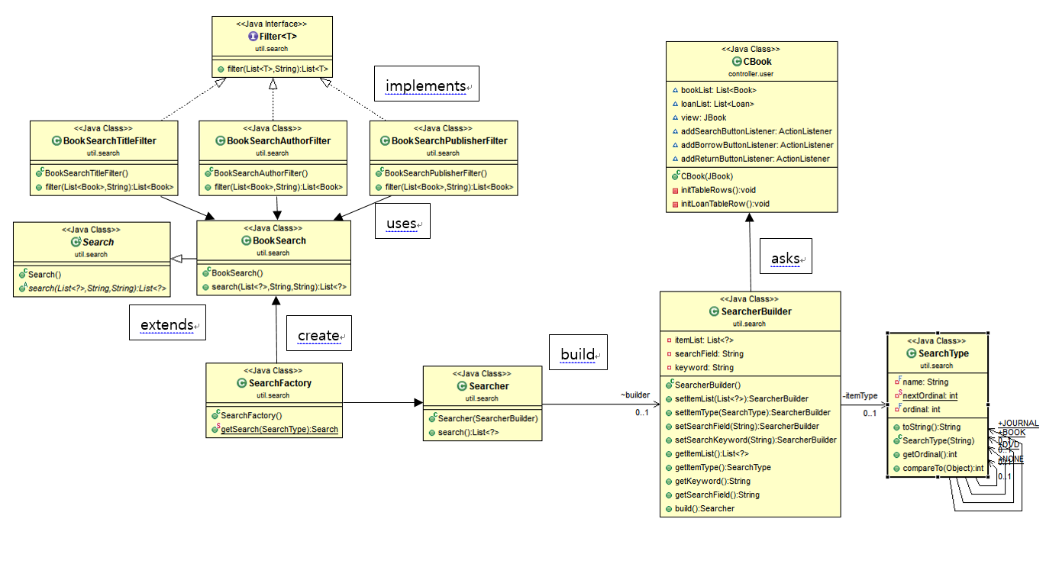

**Builder Design Pattern**

<Figure 4.1 – Library System: Builder Design Pattern>

DVD

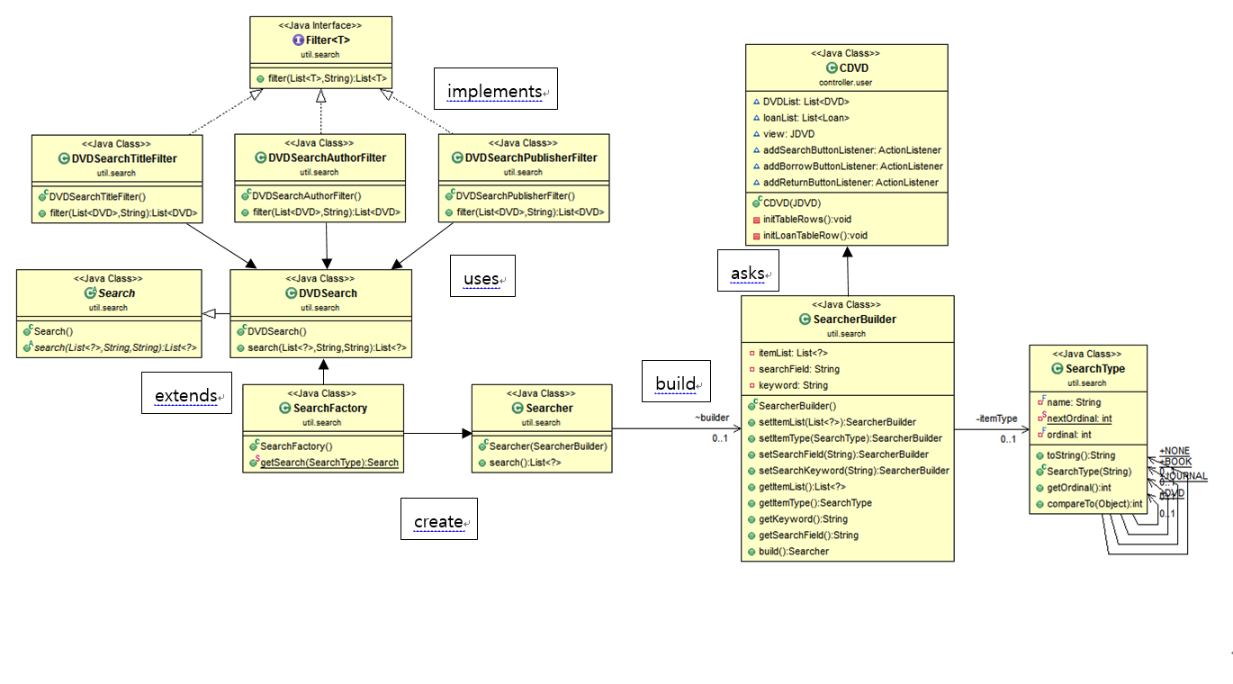

**Factory Design Pattern**

<Figure 4.2 – Library System: Factory Design Pattern>

Journal

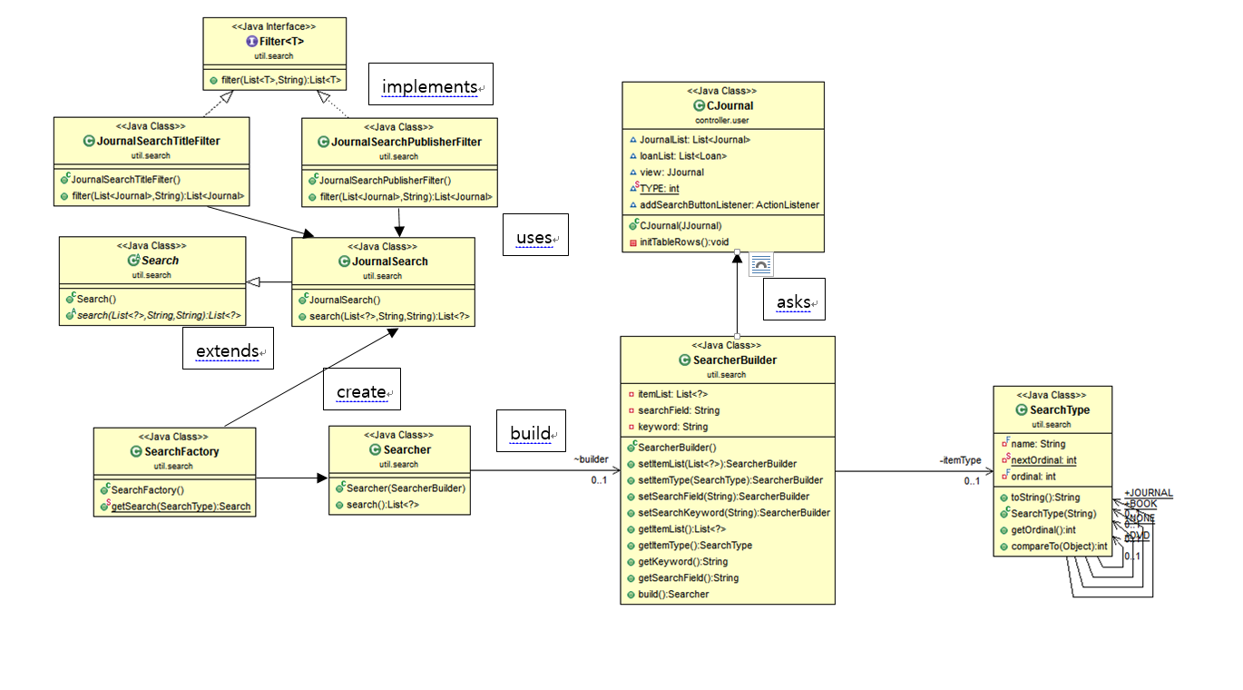

**Filter Design Pattern**

<Figure 4.3 – Library System: Filter Design Pattern>

**Design Pattern Applied**

In the fourth and final iteration we didn’t add new functions. However, we applied three different design patterns. The first design pattern is the builder design pattern. Builder design pattern separates the construction of a complex object from its representation so that the same construction process can create different representations.

<Figure 4.4 – Builder Design Pattern Structure>

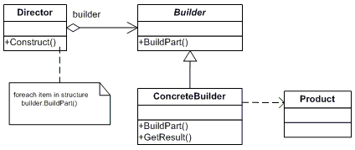

The builder, which is the CBook class in our case, specifies the requirements from the search builder. The concrete builder, which is the SearchBuilder for our system, constructs and assembles the product for Searcher class. Also the SearchBuilder provides methods for retrieving the product (getKeyword(), getItemList(), getItemType(), getSearchField()). The product, which is the search type in our case, includes the constituent parts for producing the final result (in our case it would be the type of item).

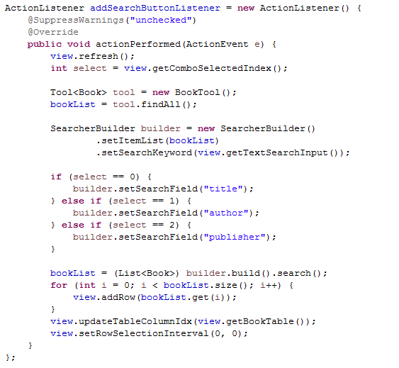

<Figure 4.3 – Builder Design Pattern: CBook>

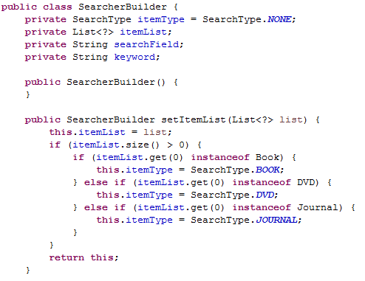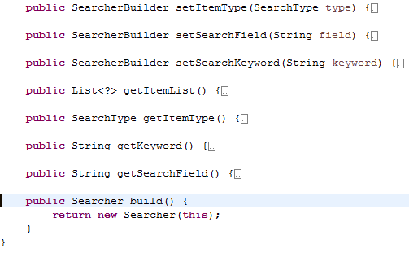

<Figure 4.4 – Builder Design Pattern: SearchBuilder>

After setting the build, like the figure 4.3 above, and by returning *this* from the set method, we can use the build() method implemented in the SearcherBuilder class to return the Searcher object.

Another design pattern we applied is the filter design pattern:

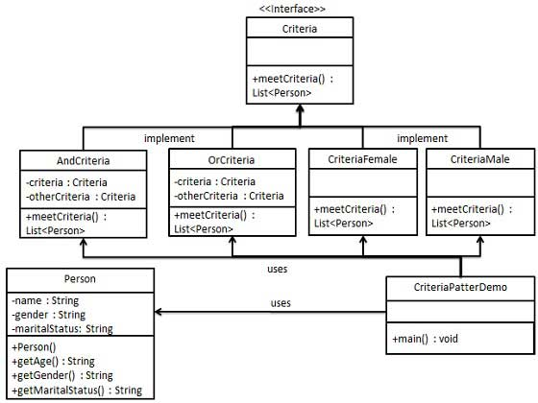

<Figure 4.5 – Filter Design Pattern Structure>

Filter design pattern enables developers to filter a set of objects using different criteria and chaining them in a decoupled way through logical operations. This pattern combines multiple criteria to obtain single criteria. In the Library System, we have the book, DVD, and journal class on which criteria is to be applied on.

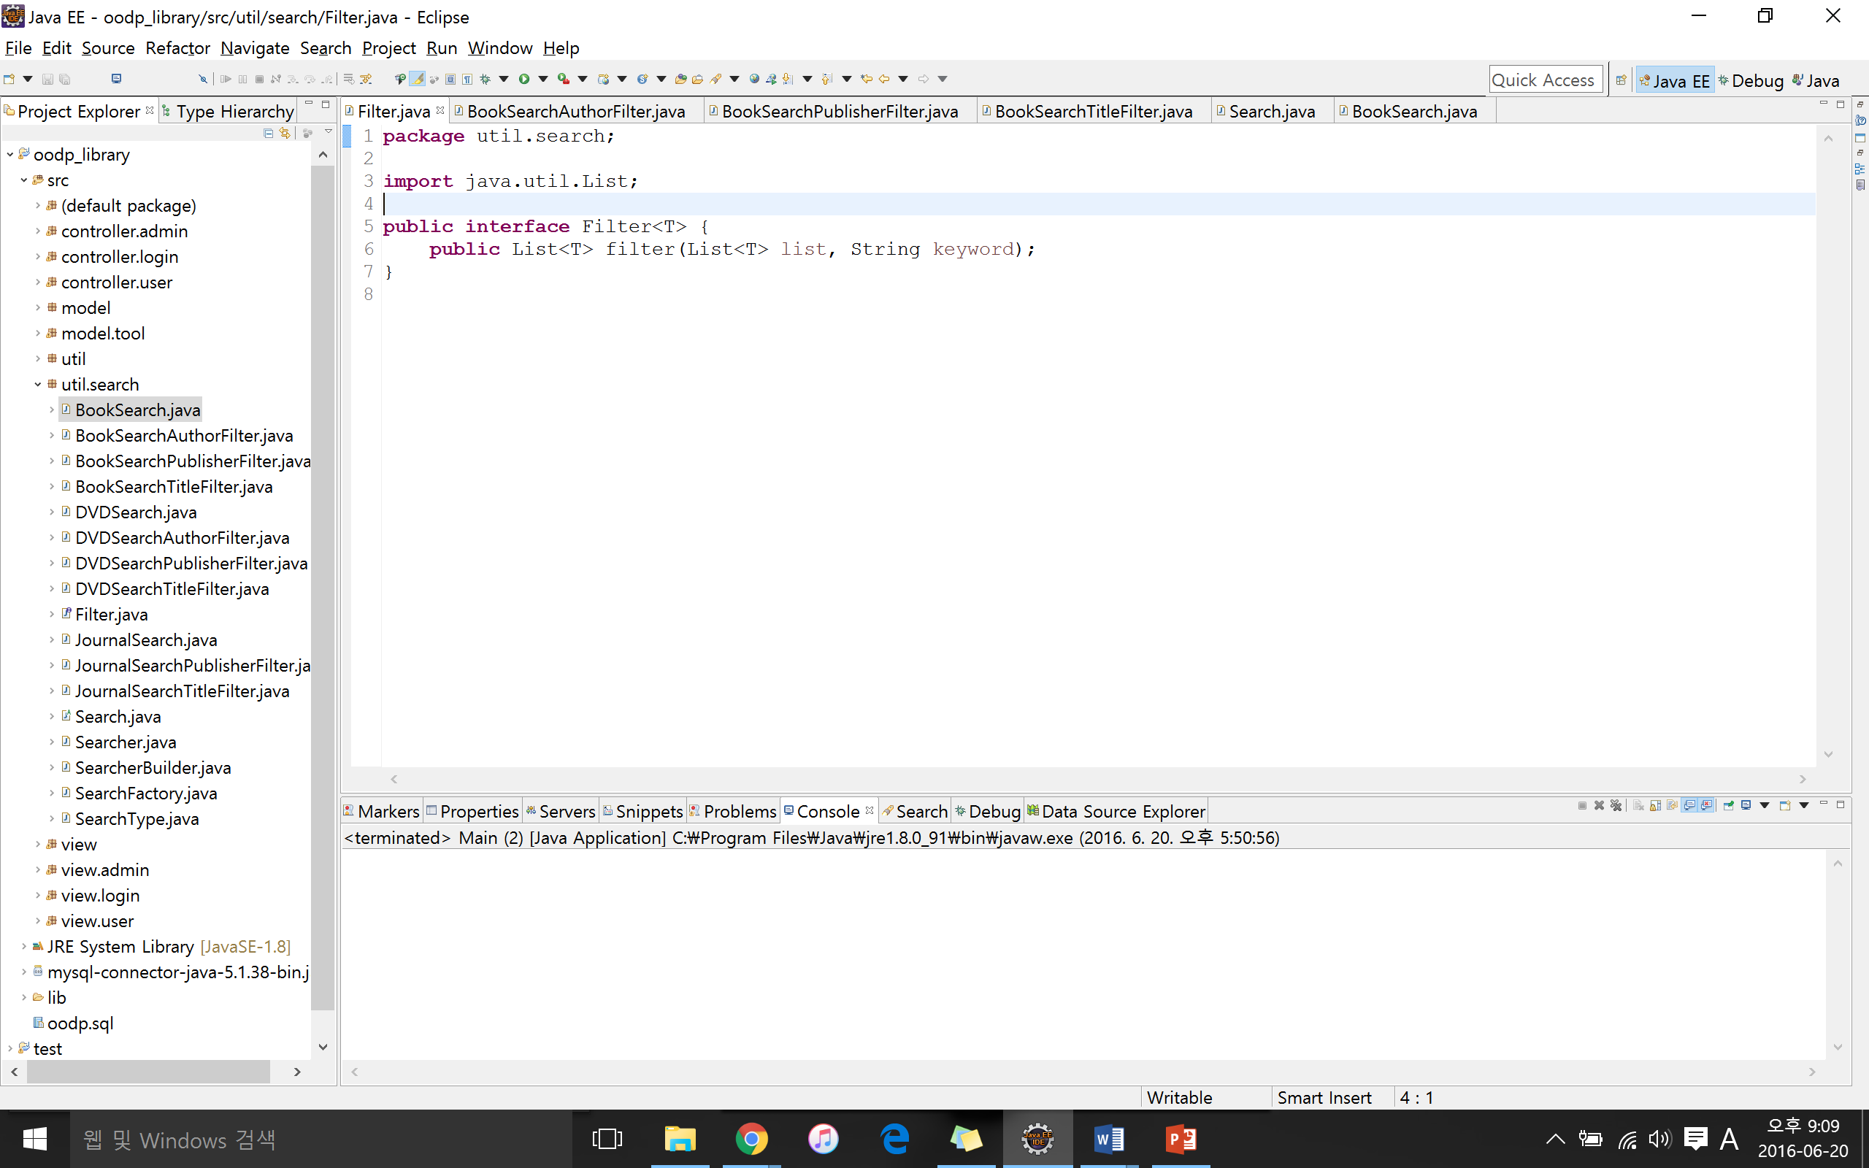

<Figure 4.6 – Filter Design Pattern: Filter>

We first created the interface for filter

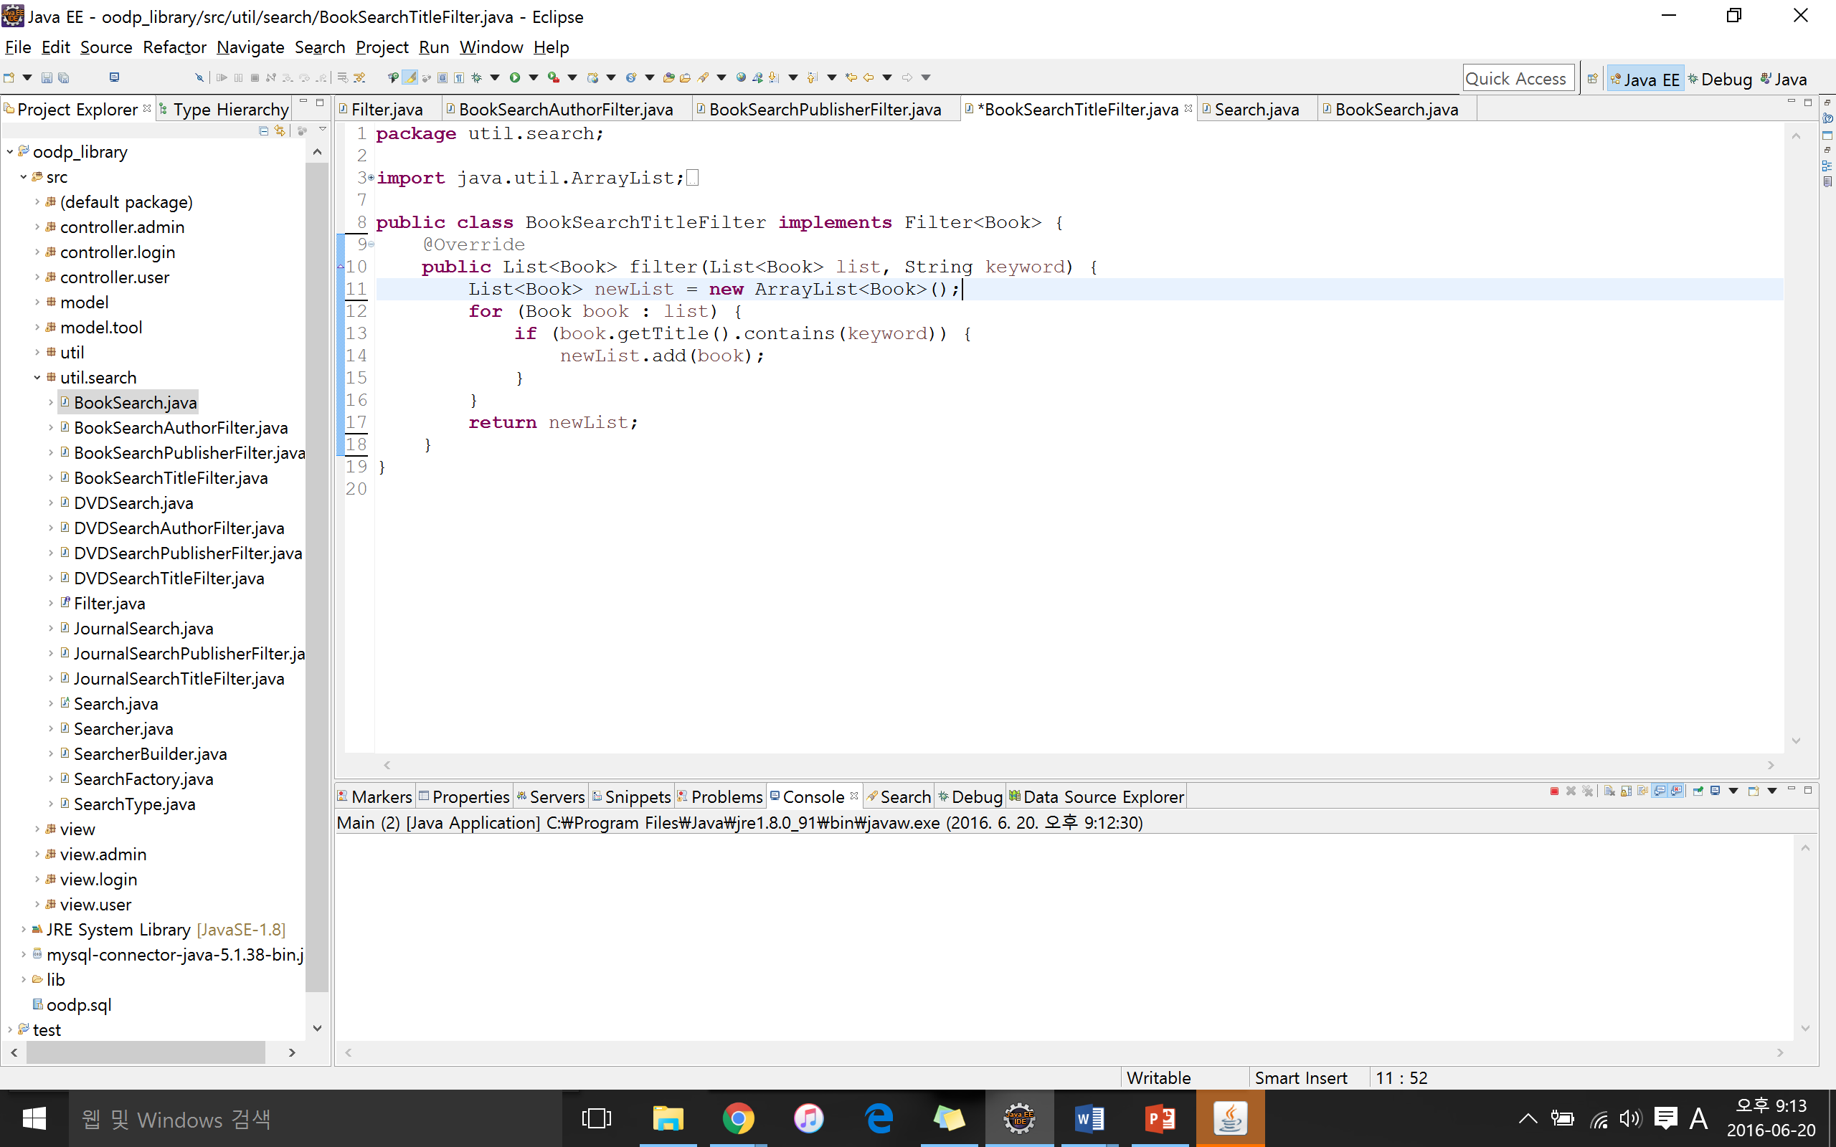

<Figure 4.7 – Filter Design Pattern: BookSearchTitleFilter>

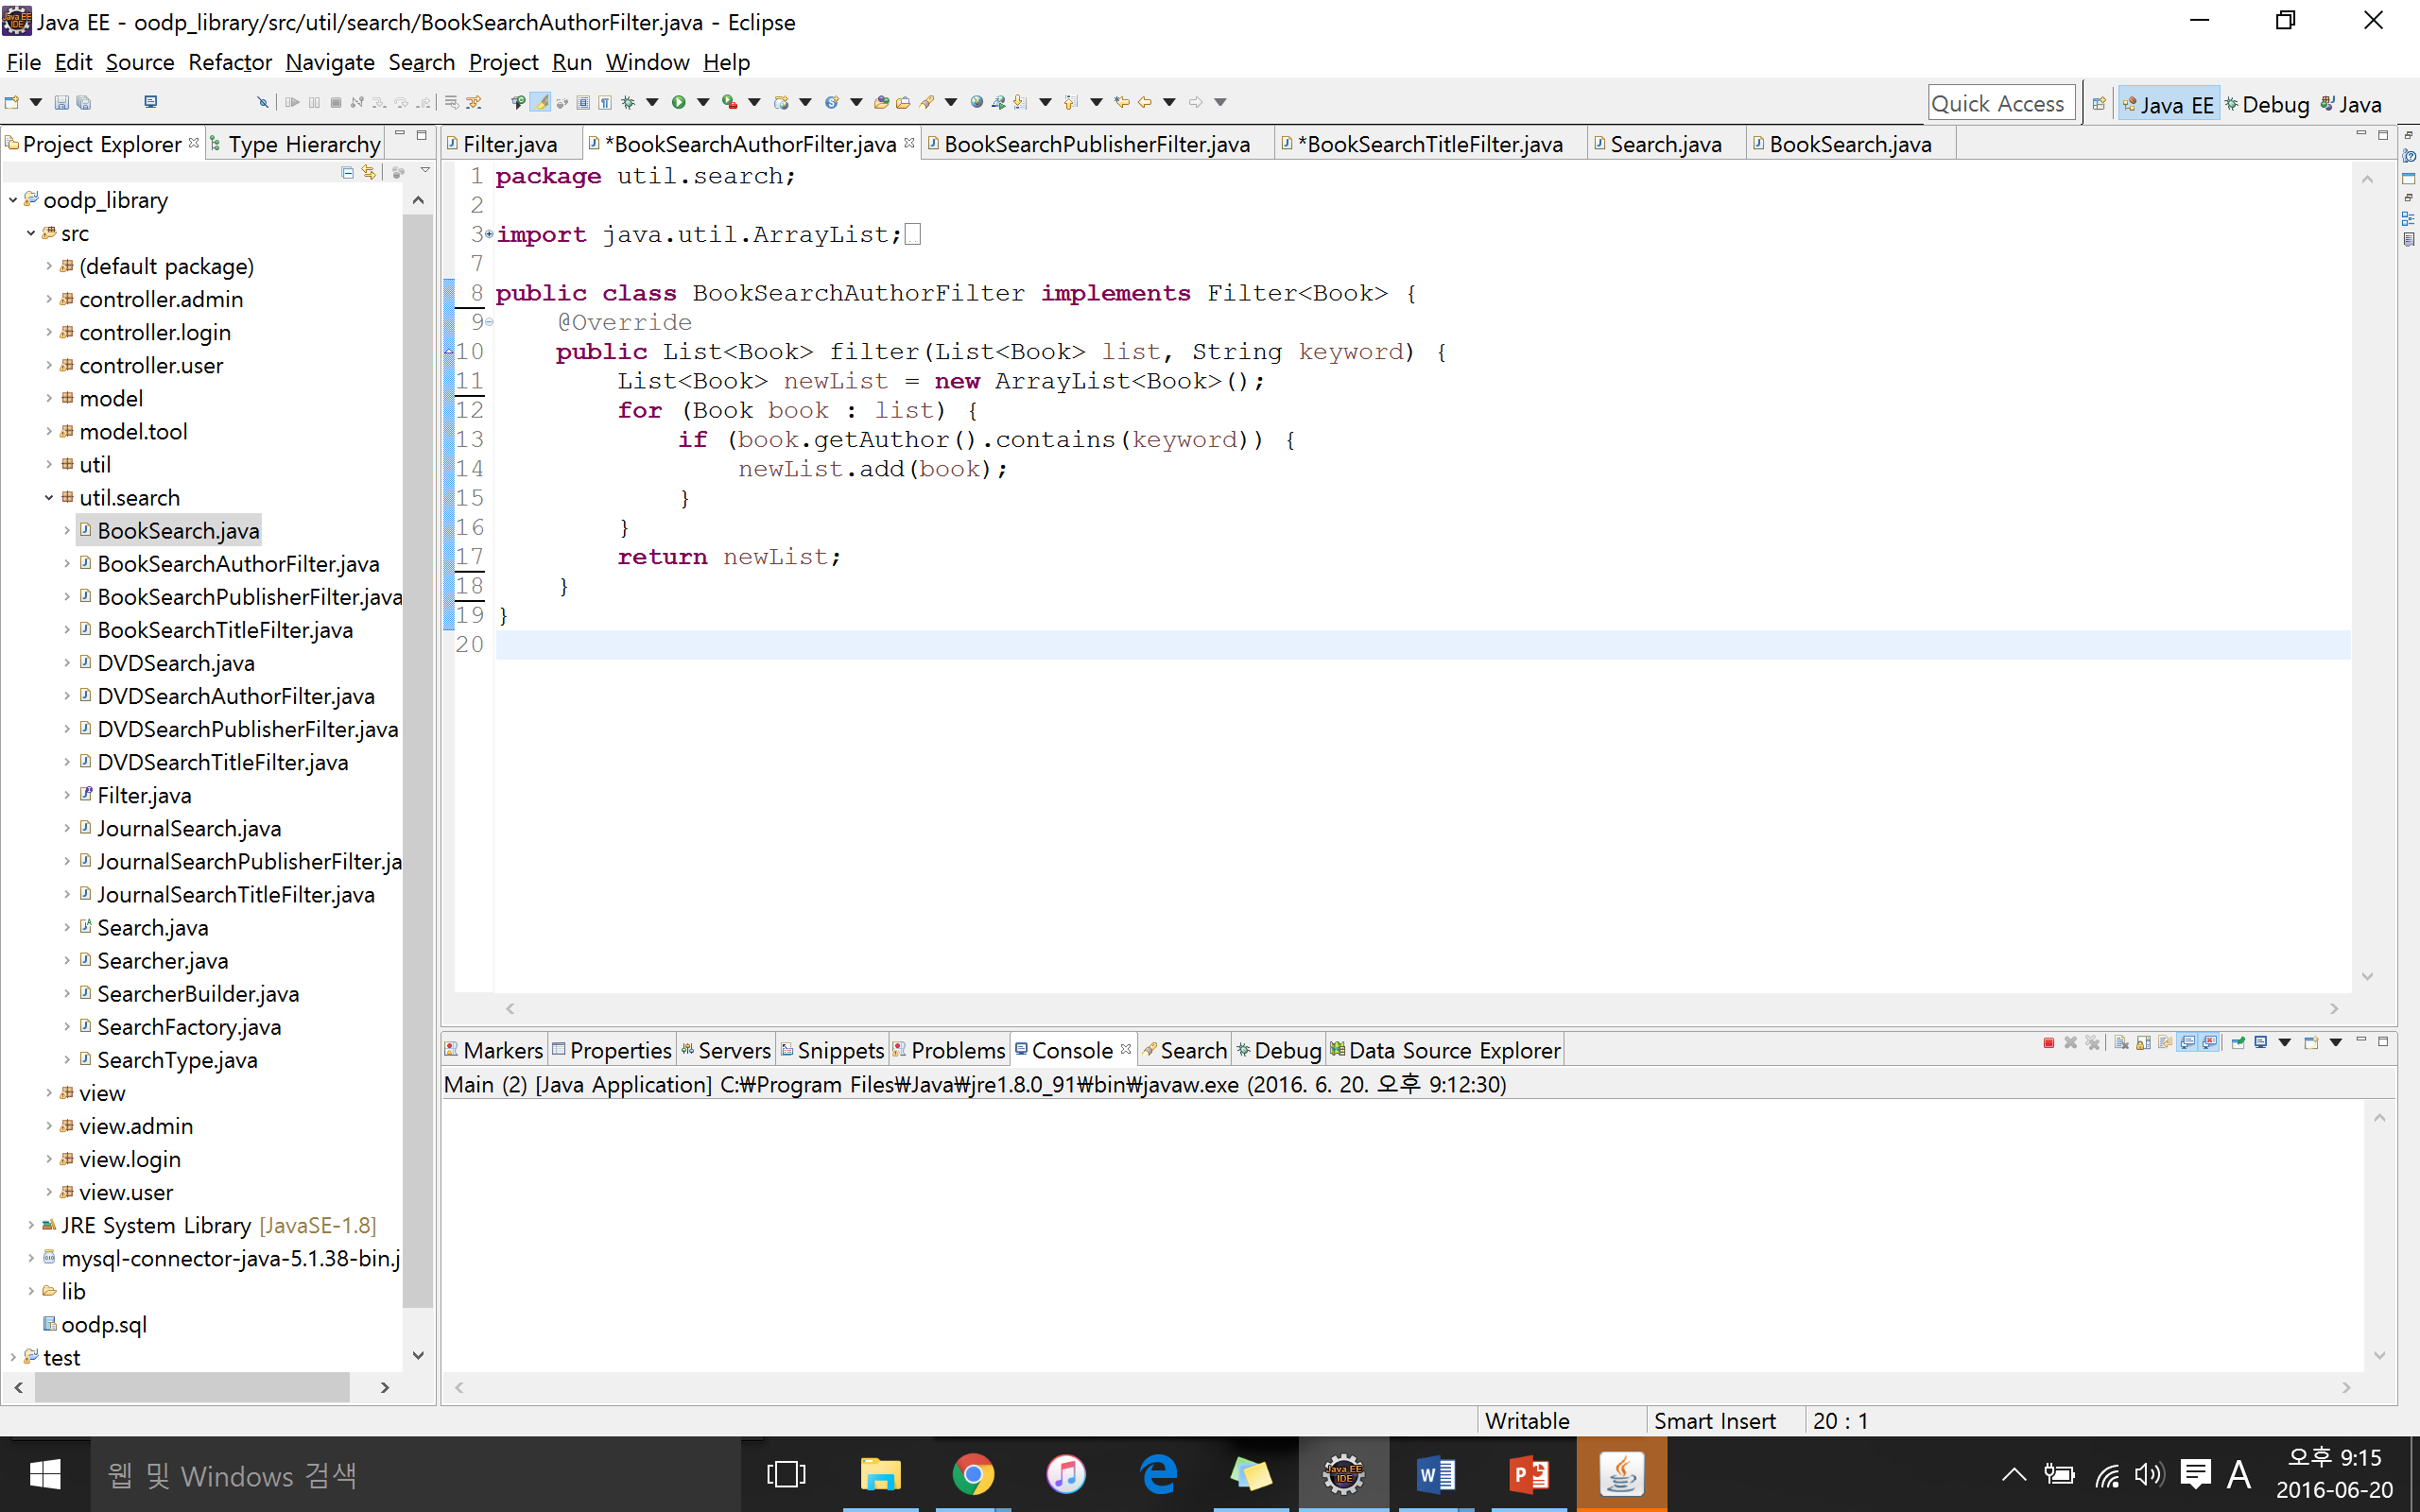

<Figure 4.8 – Filter Design Pattern: AuthorSearchTitleFilter>

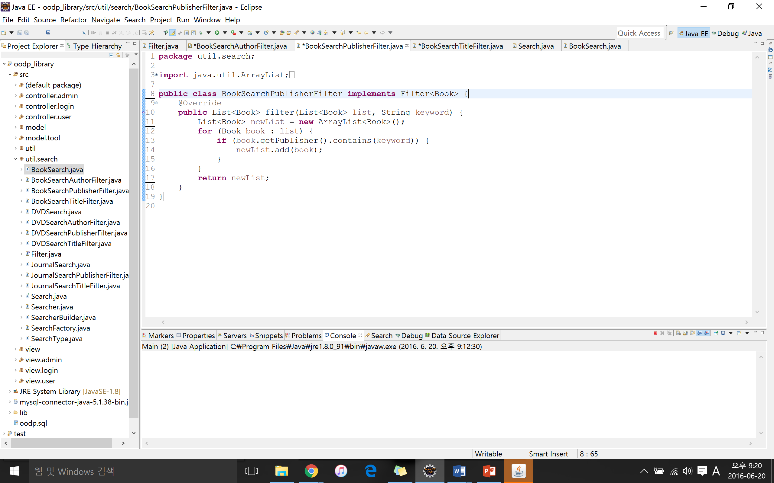

<Figure 4.9 – Filter Design Pattern: PublisherSearchTitleFilter>

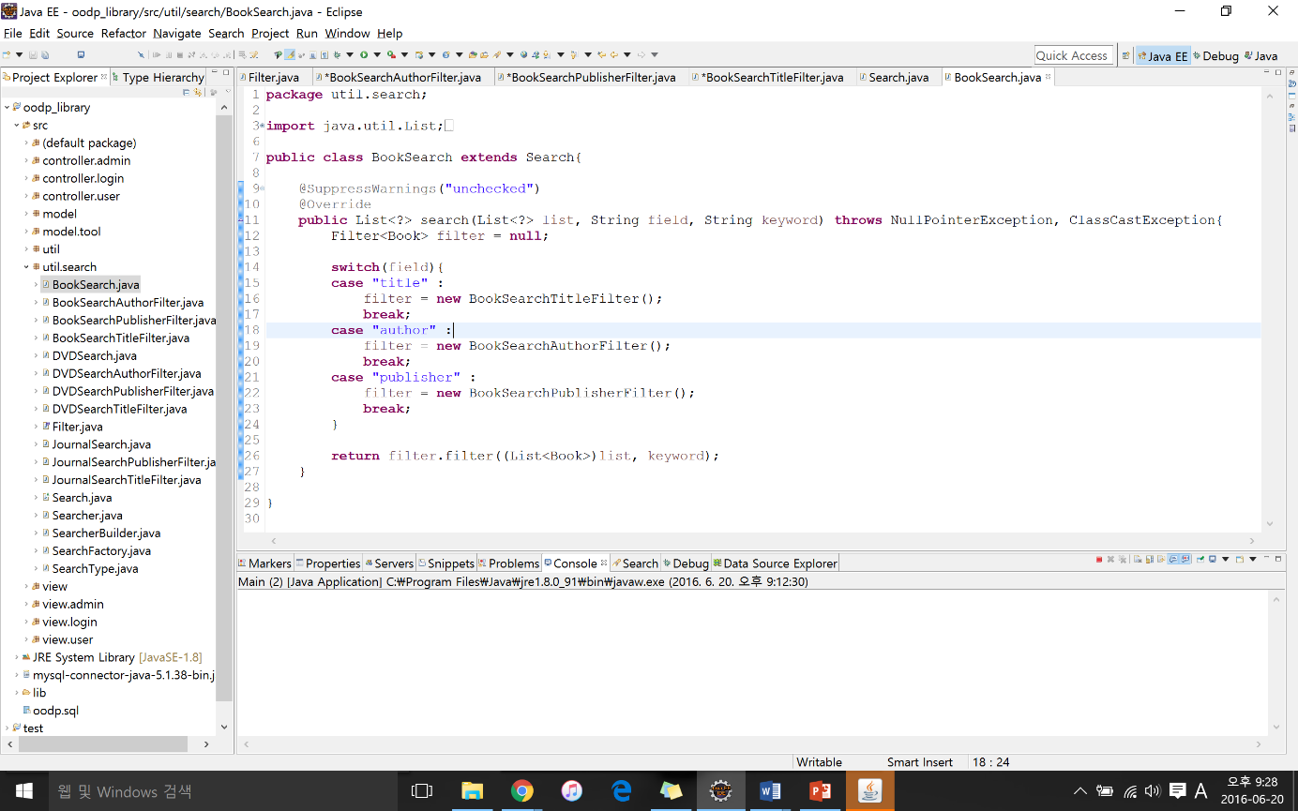  
The we created concrete classes implementing the criteria interface such as by title, author or publisher.

<Figure 4.10 – Filter Design Pattern: BookSearch>

This design pattern allows us to use different criteria and their combination to search books, DVDs and journals.

The Last design pattern we applied for this iteration is the factory design pattern:

<Figure 4.11 – Factory Method Design Pattern Structure>

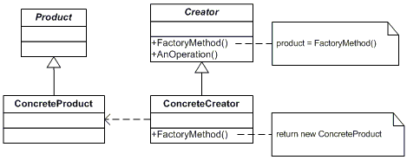

Factory design pattern define an interface for creating an object, but let subclasses decide which class to instantiate. Factory method lets a class defer instantiation to subclasses.

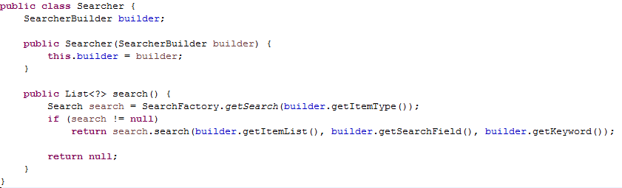

<Figure 4.12 – Factory Method Design Pattern: Searcher>

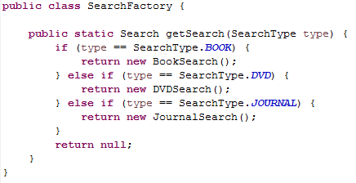

<Figure 4.13 – Factory Method Design Pattern: SearchFactory>

The SearchFactory class uses getSearch() method to obtain the type of search including book, DVD and journal. However, when the getSearch method is used, it creates a new instance like BookSearch(), DVDSearch(), or JournalSearch() which are considered products in the factory design pattern.

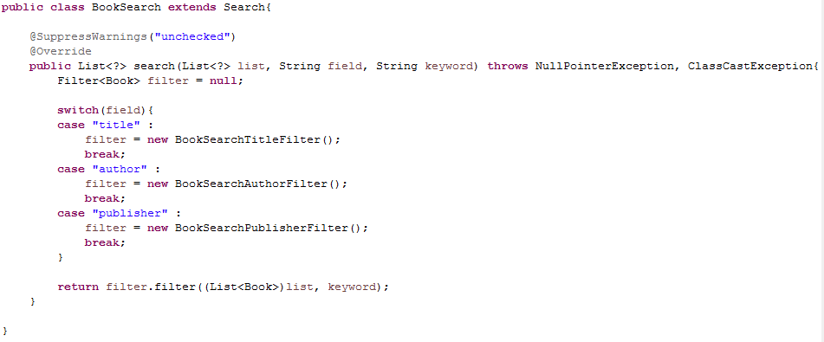

<Figure 4.14 – Factory Method Design Pattern: BookSearch>

From the instance of BookSearch that was created, filter is applied as well to create instance of book search according to the title, author or publisher. So the product resulting are BookSearchTitleFilter instance, BookSearchAuthorFilter instance and BookSearchPublisherFilter instance.

**Screenshots**

Register/ Log in

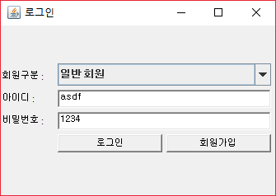

Admin Interface: Member management

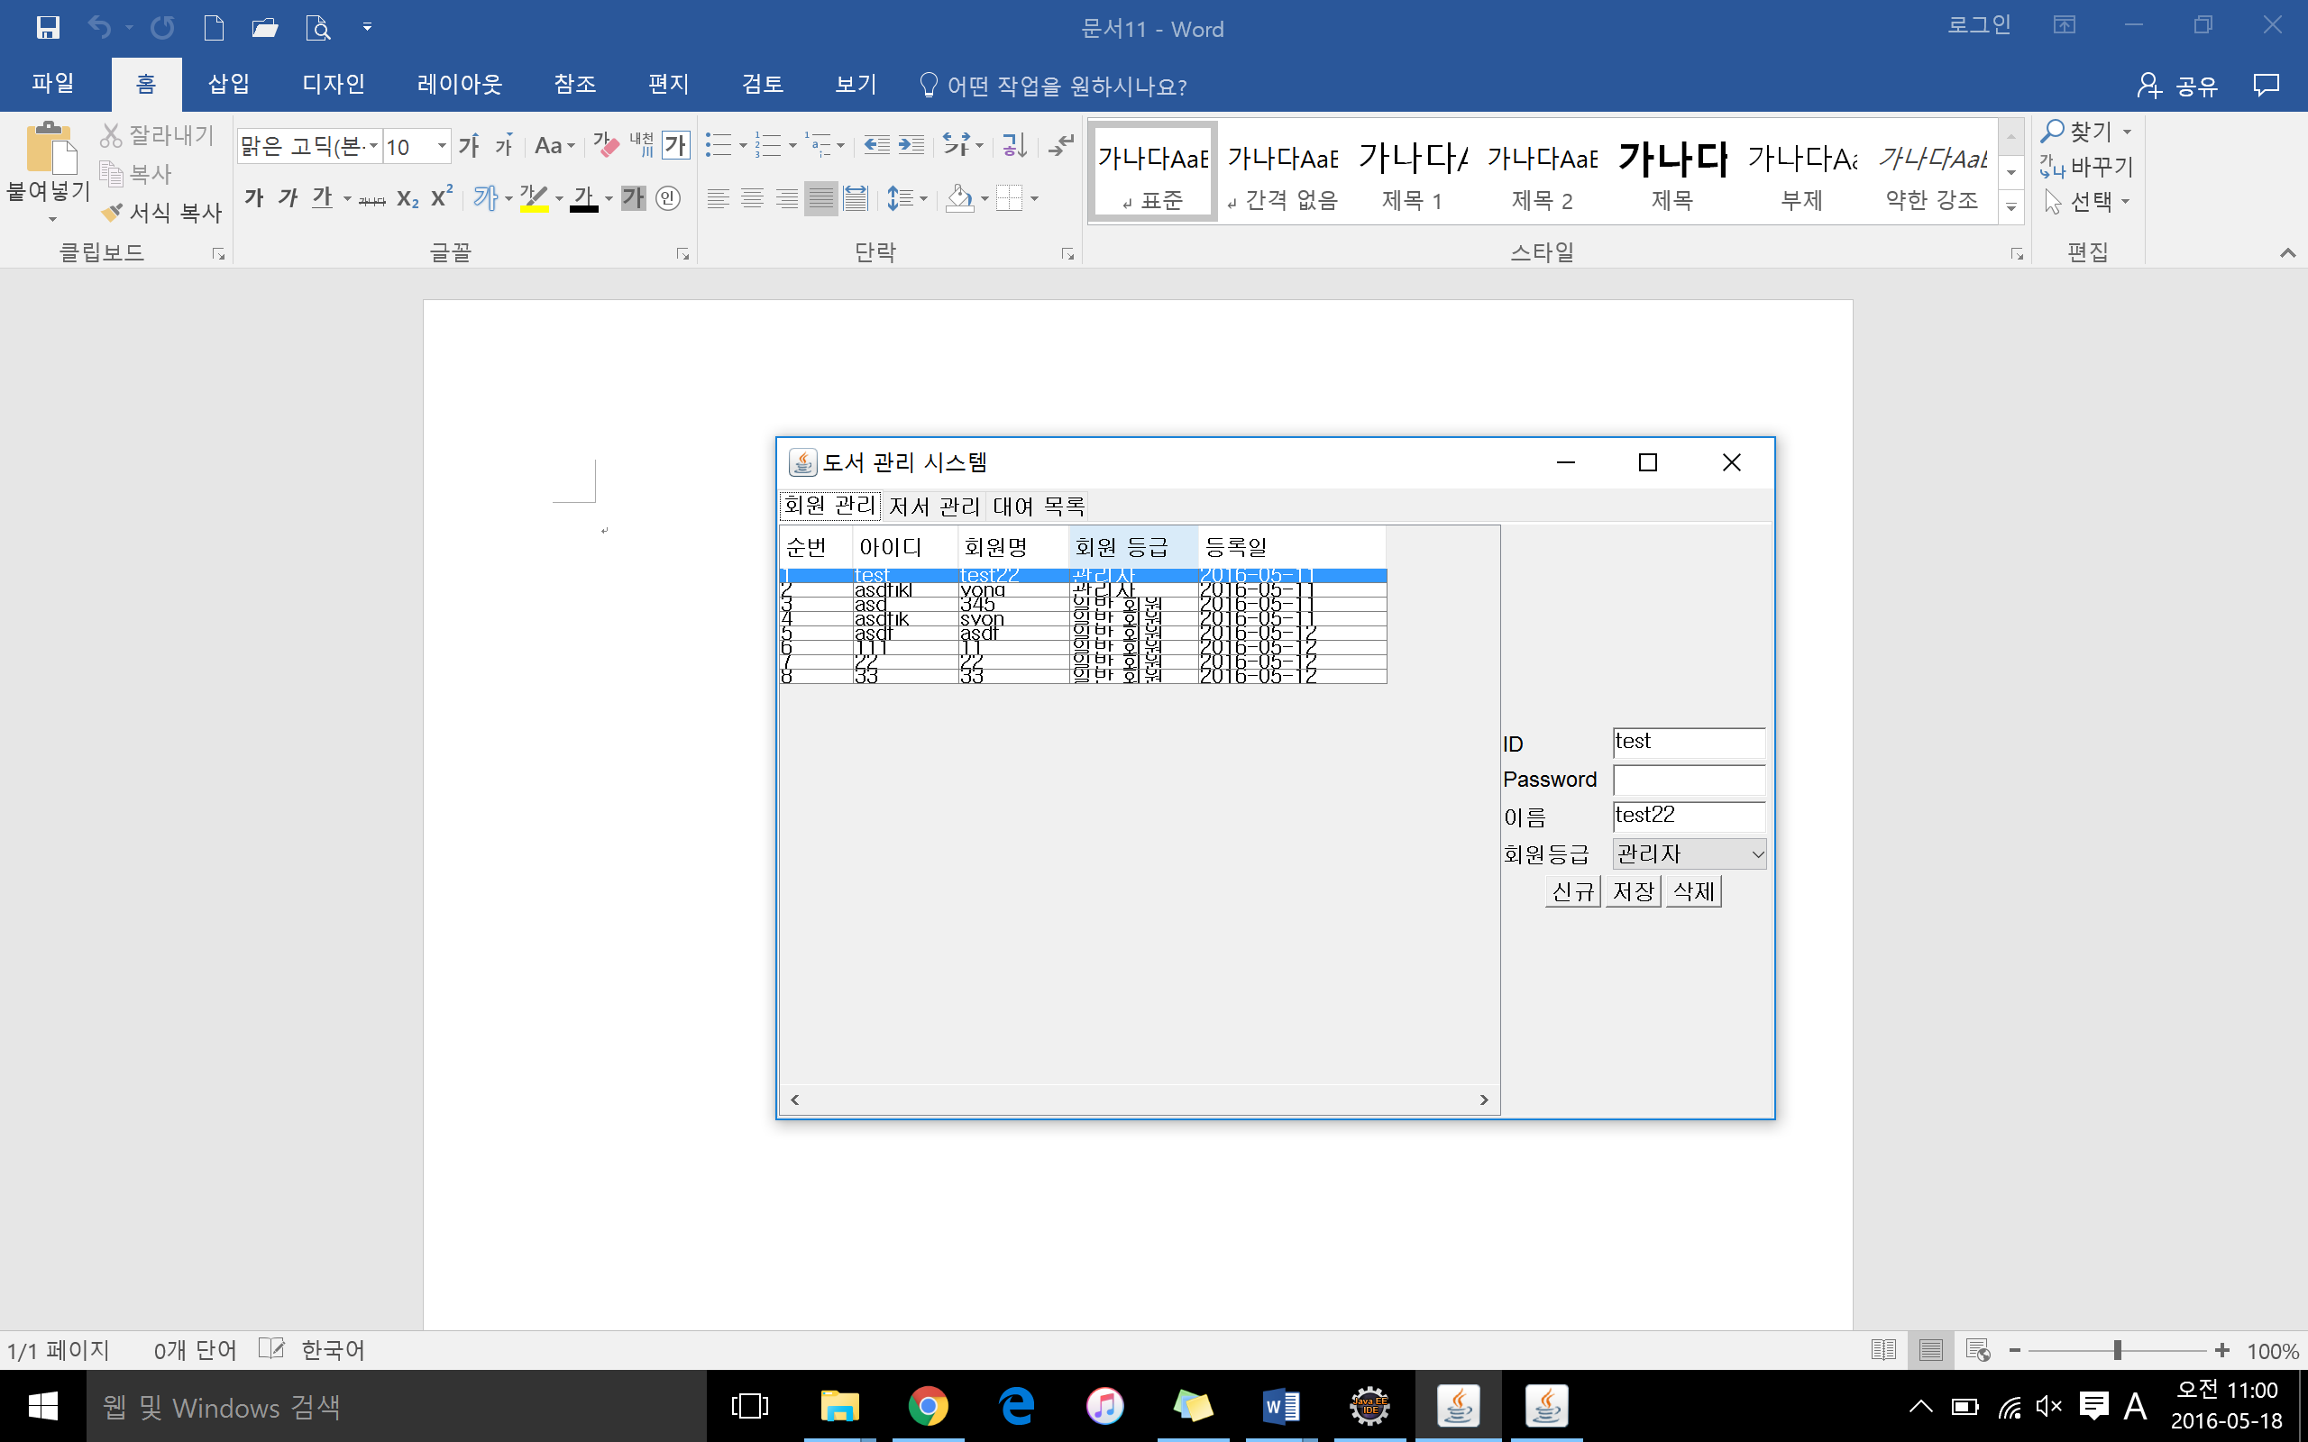

Admin Interface: Book Management

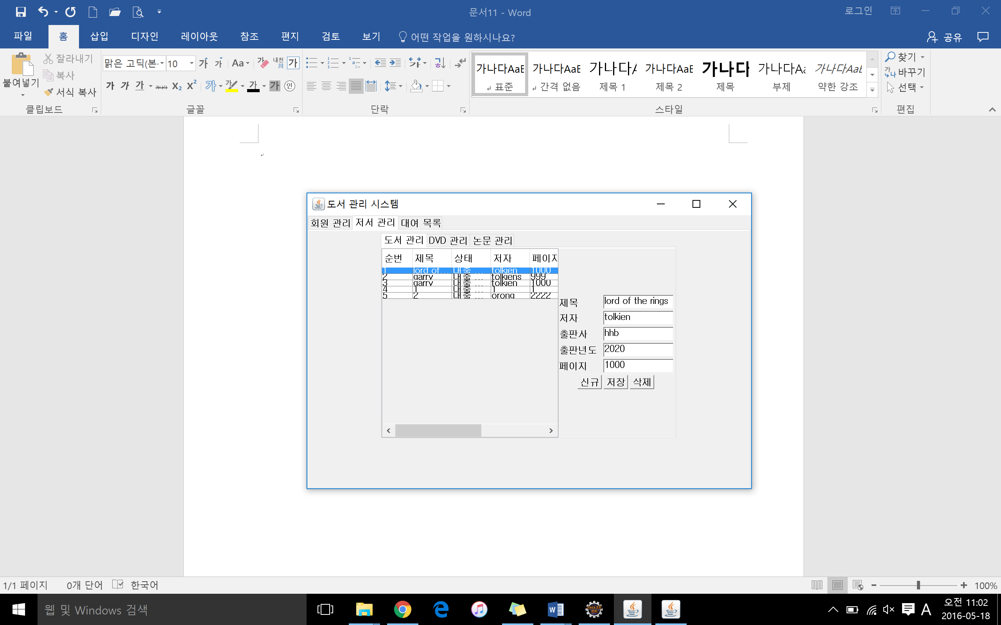

Admin Interface: DVD Management

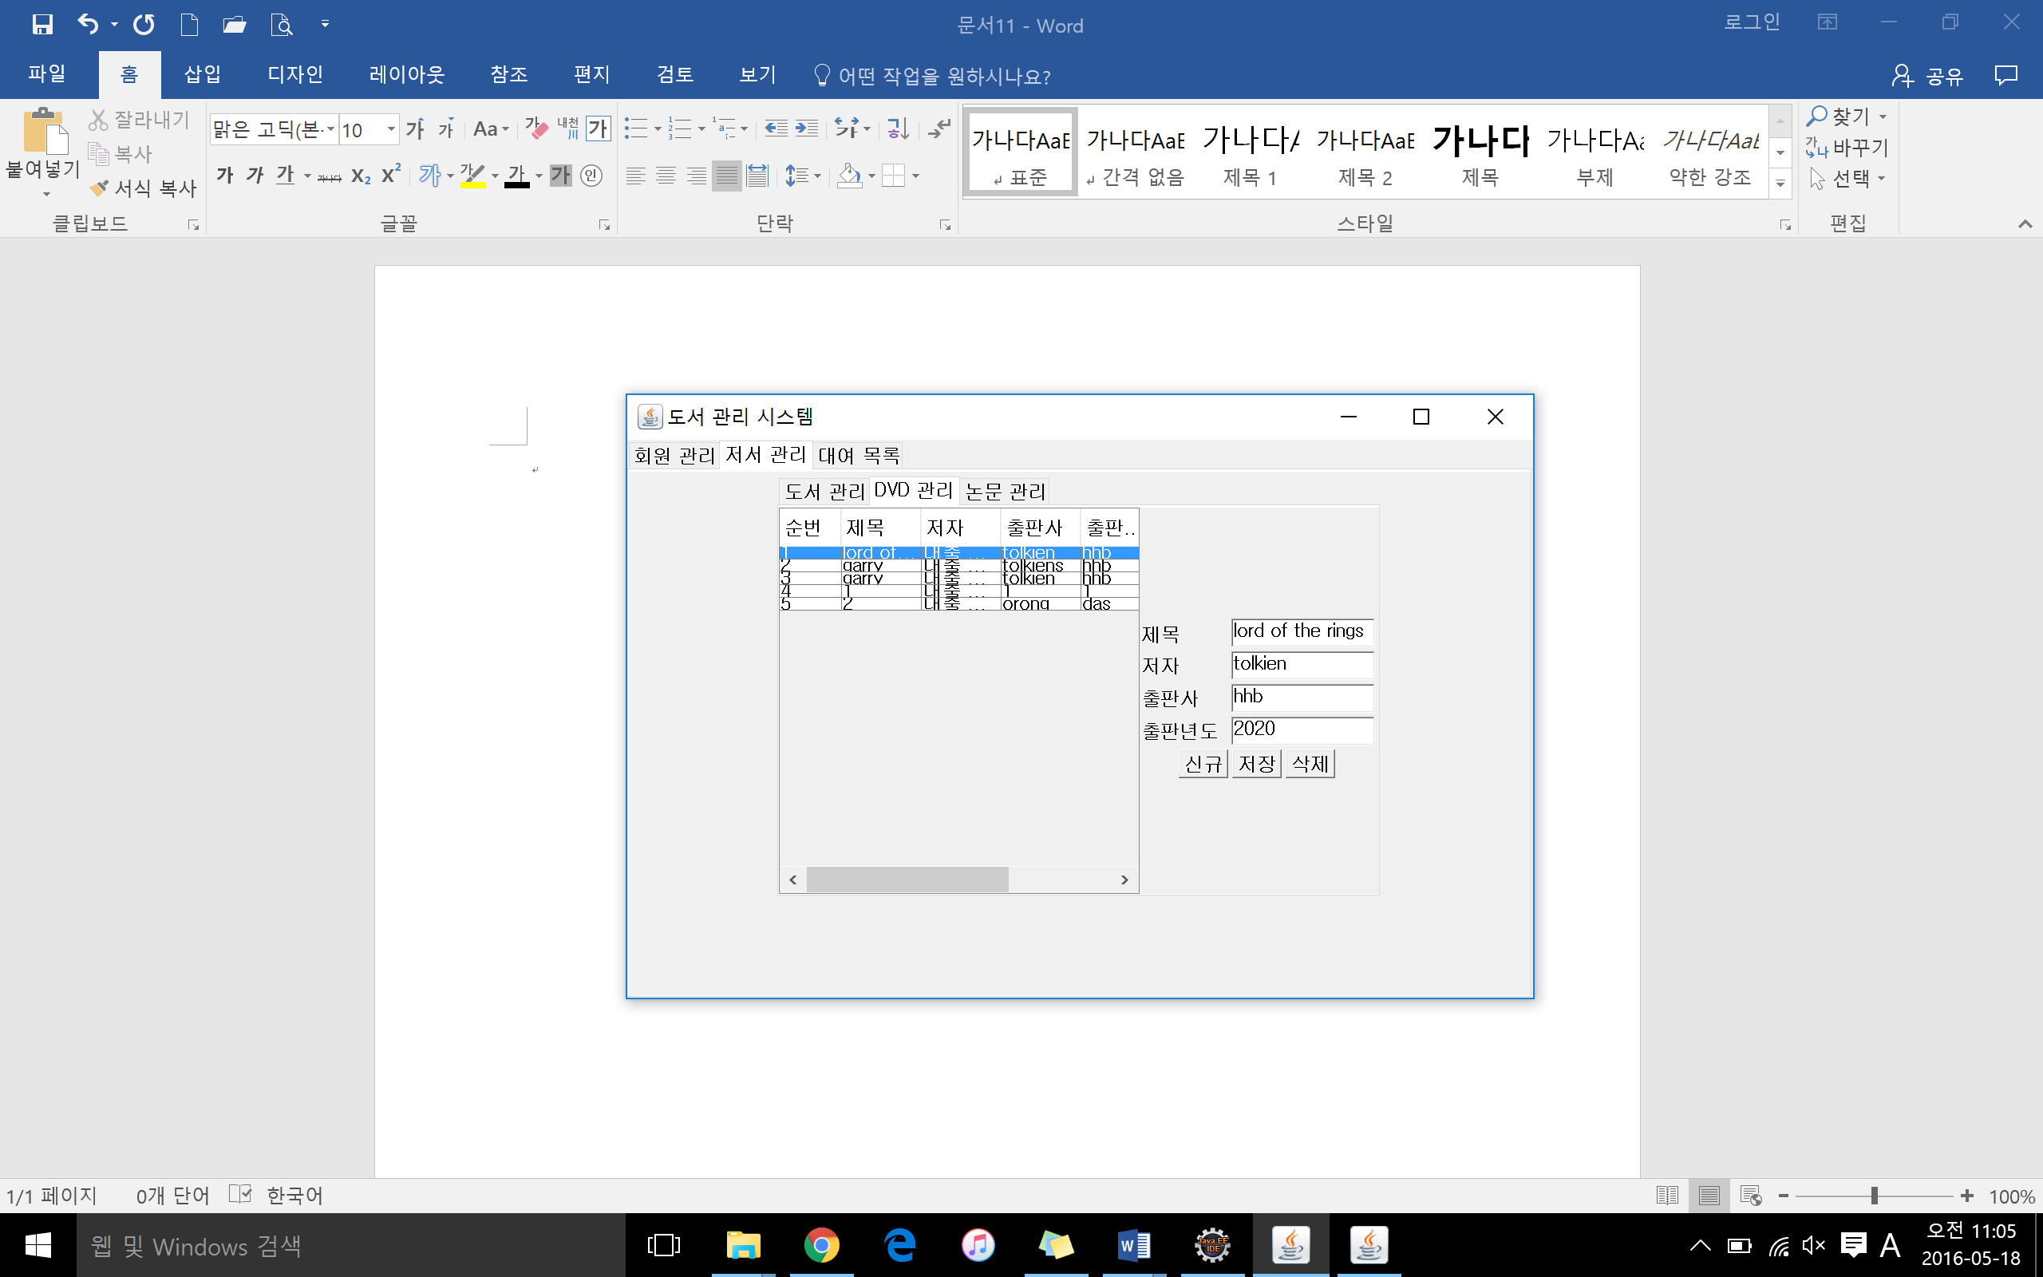

Admin Interface: Journal Management

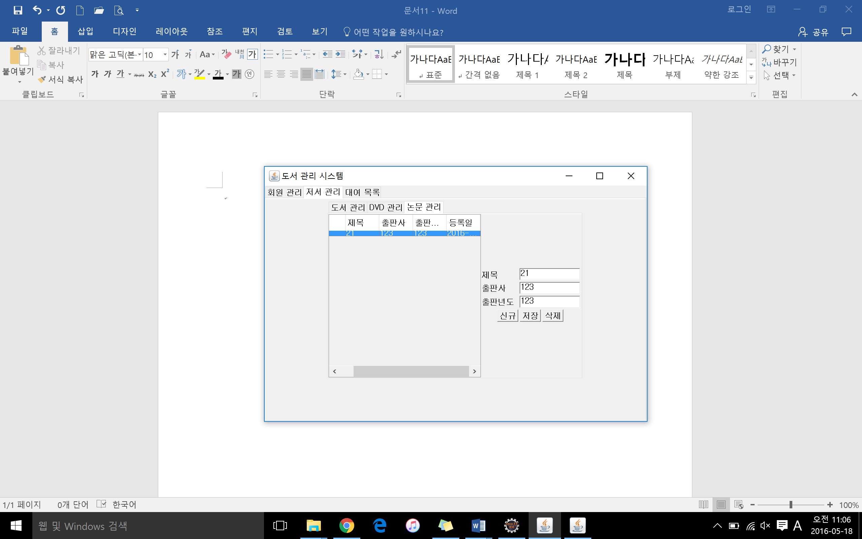

Admin Interface: Borrowed Item Management

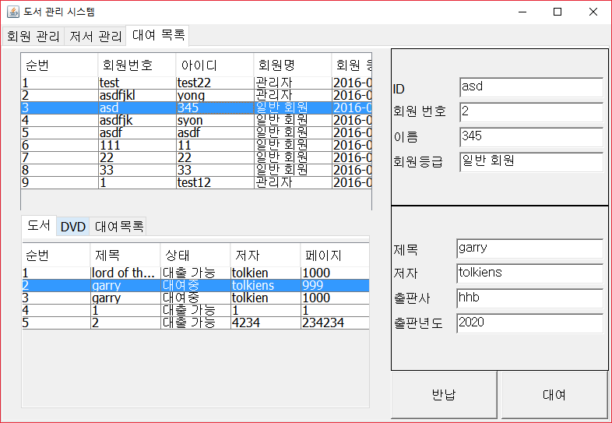

User Interface: Book Management

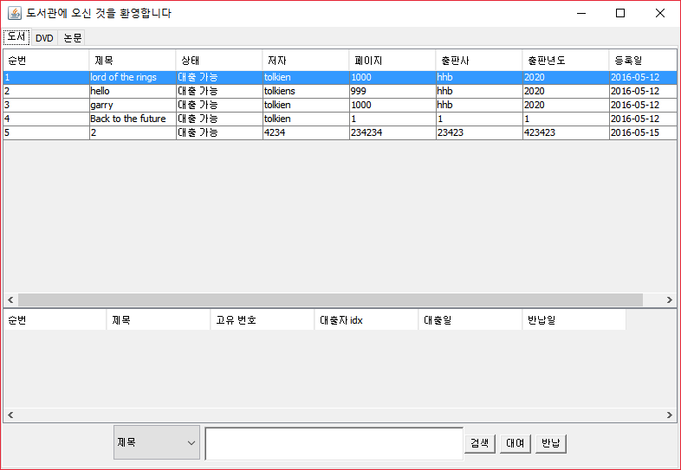

User Interface: DVD Management

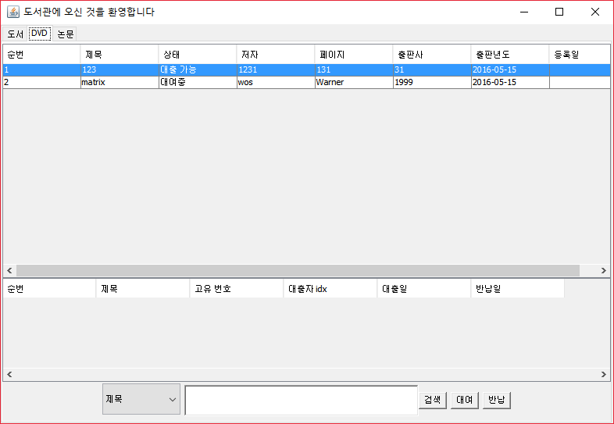

User Interface: Journal Management

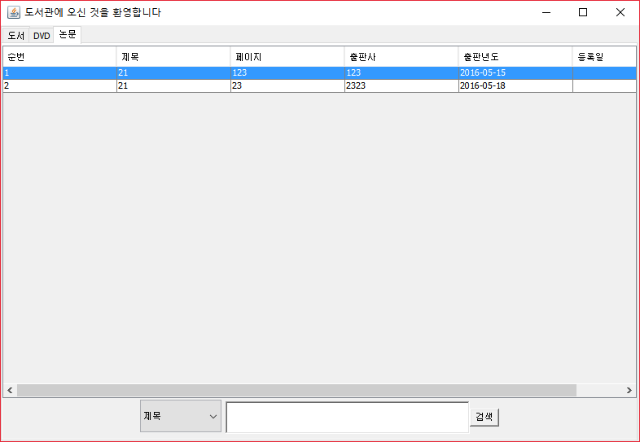

User Interface: Search

